

**TIS2151 - Web Application Development**

Group Project

Sushi Sama

Prepared by:

|  |  |  |  |
| --- | --- | --- | --- |
| **STUDENT ID** | **NAME** | **EMAIL** | **PHONE** |
| 1171101353 | CHAI KAR SING | 1171101353@student.mmu.edu.my | 010-3989634 |
| 1171303322 | LIM GUAN CHENG | 1171303322@student.mmu.edu.my | 016-3914500 |
| 1151205451 | LOO YUAN JUN | 1151205451@student.mmu.edu.my | 012-4012938 |
| 1171101517 | MICHELLE CHAI MEI WEI | 1171101517@student.mmu.edu.my | 016-5727809 |
| 1171100363 | WONG ZI JIANG | 1171100363@student.mmu.edu.my | 018-3710781 |

Contents

1. Introduction 2

1.1 Problem Statement 2

1.2 Objectives 2

2. Proposed Solution 3

2.1 Analysis on websites 3

2.2 Use-case diagram 9

2.3 Distribution of development / coding tasks 11

3. Implementation 12

3.1 HTML 12

3.2 CSS 14

3.3 Client-Side Script 15

3.4 Server-Side Script 17

3.5 Database 20

3.6 Final product 25

4. Limitations and Future Improvements 44

5. Discussion and Conclusion 45

6. Appendix – HTML validation (Assignment 1) 46

# Introduction

## Problem Statement

After analyzing a few restaurants’ websites, our group realized that the functionalities of these websites are severely limited and are usually used merely as a display of information about their companies, location, menu, careers, catering and more. To make it worst, Sakae Sushi do not even display the menu served in their website.

Other than that, the websites lack interactivity and do not retain the attention of users. For example, Rakuzen, Sakae Sushi and Sushi Zanmai have primitive website designs, which consists of a header photo, a nav bar, content and footer. In fact, Rakuzen and Sushi Zanmai shares a similar unattractive design layout, where the interface does not appeal to users visually.

## Objectives

1. To have useful functions that can attract and retain users
2. To have aesthetically pleasant interface and interactive elements

# Proposed Solution

## Analysis on websites

Since the nature of our restaurant is Japanese cuisine, our group have visited several websites of popular Japanese restaurants in Malaysia, such as Sakae Sushi, Rakuzen, Sushi Zanmai, and last but not least Sushi Mentai. A table that summarize our analysis is on the final page of this section.

* + 1. Sakae Sushi

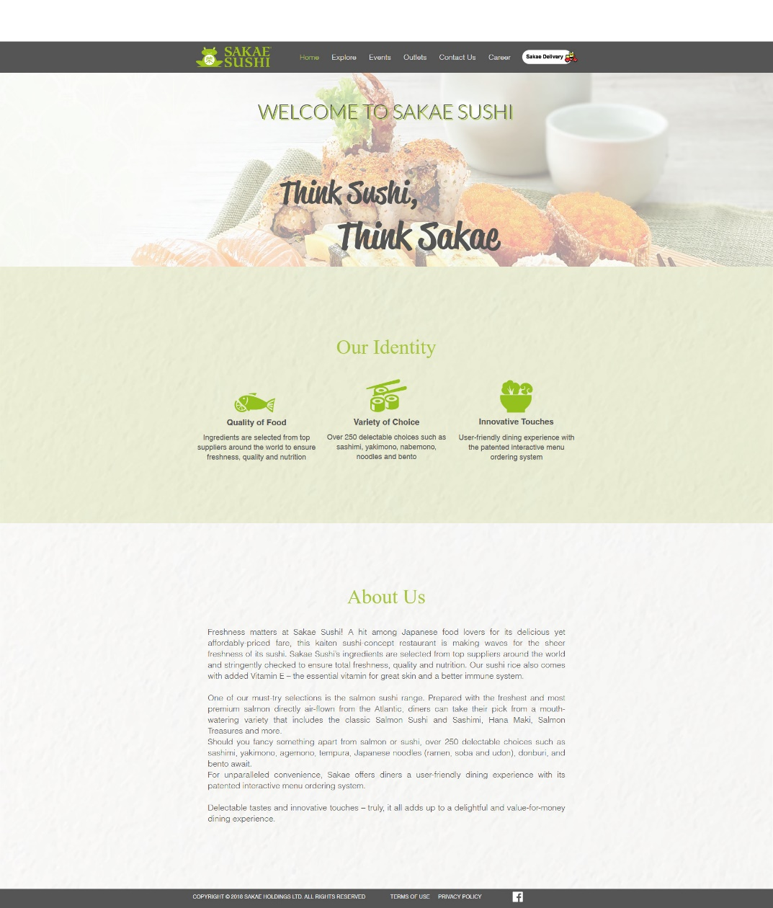

Figure 1: Screenshot of Sakae Sushi website

As you can see from the above figure, the website is plain and boring; The design layout is simple, the color palette is only Sakae Sushi’s signature green, white and black. The website also does not have a menu display.

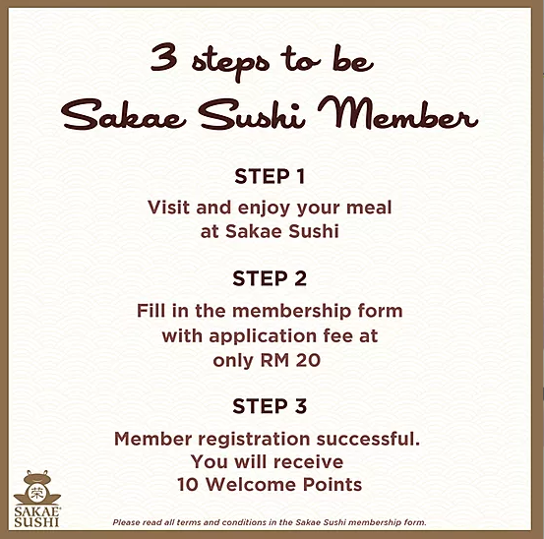

Figure 2: Pop up from Sakae Sushi website

When you first visit the website, a pop-up will appear; promoting the membership of Sakae Sushi as shown in Figure 2. However, the application of membership can not be done through online. When you click on the “Explore” -> “SAKAECard” on the navigation card, it displays the privilege of being a member, a link to its membership portal, and the terms and conditions of SAKAECard membership.

Other than that, when you click on the button for Sakae Delivery, it redirects you to another website, where it requires you to sign in with an Oddle Pass. It is a login mechanism that allows customers to log in to Oddle Shops with a single set of login credentials. The website is lacking in terms of functionality.

* + 1. Rakuzen (Super Dining)

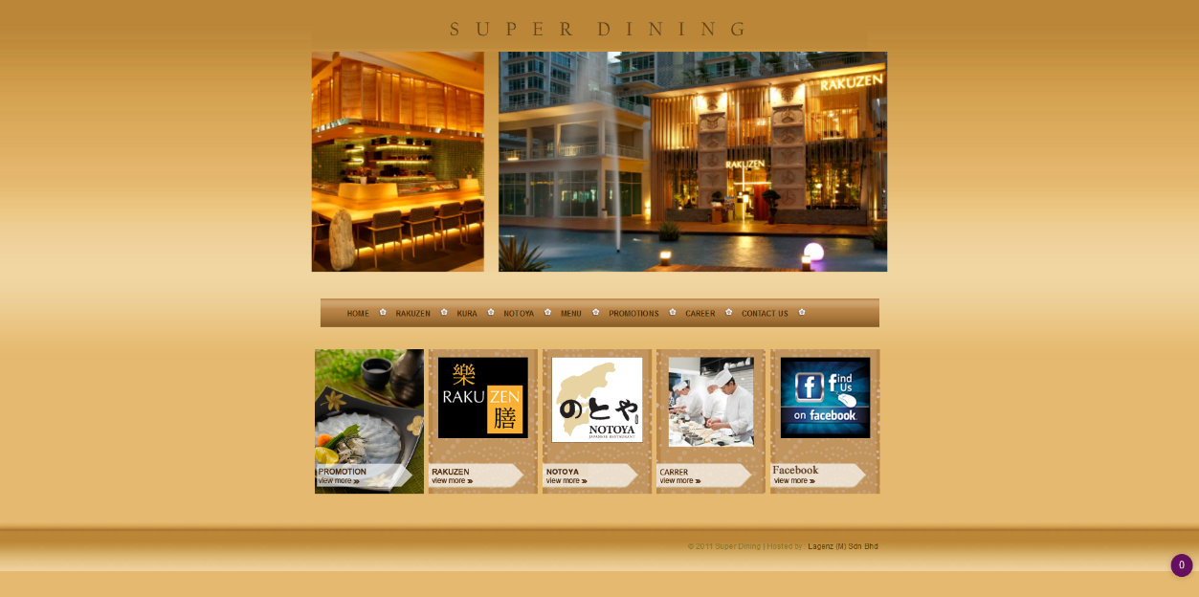

Figure 3: Screenshot of Rakuzen website

Super Dining is a group of Japanese restaurants, consisting of Rakuzen, Kura and Notoya. It is obvious from first sight that the website is not optimized for bigger screen size because of the left and right empty spaces. Among all the websites we analyzed, it has the simplest design and color theme. However, it has responsive design on both tablets and phones.

The website only displays information about its outlets, different menus, careers for the three different restaurants. The promotion page supported by promotion.php displays nothing. Other than displaying information, the website does nothing. In comparison to other modern websites, it is severely lacking in terms of functionality.

* + 1. Sushi Zanmai

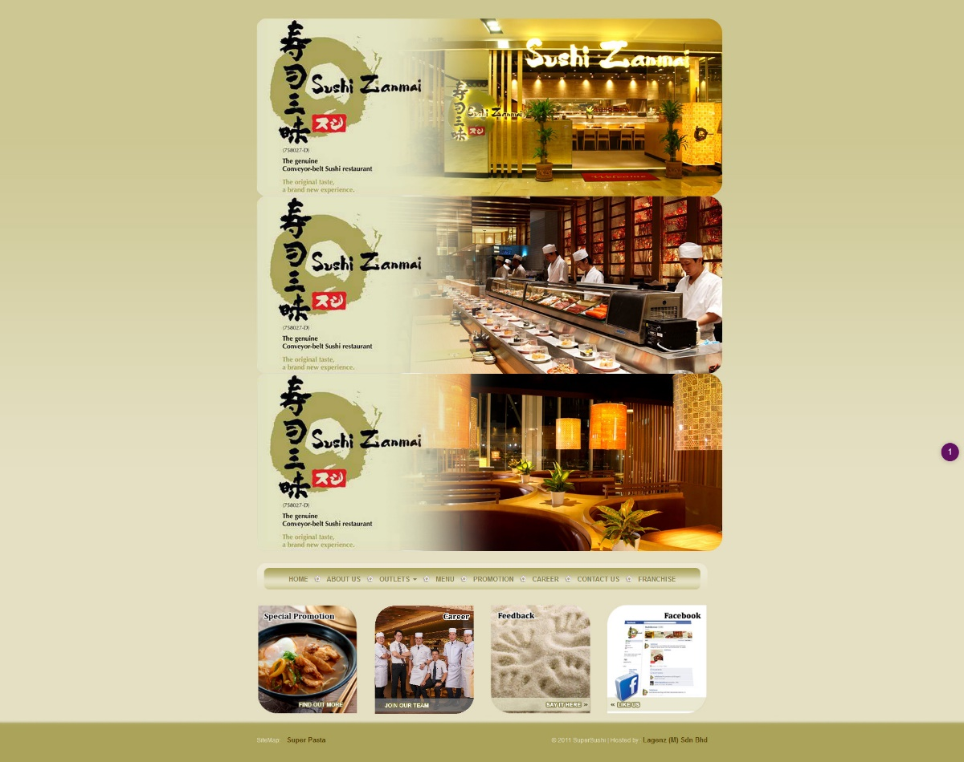

Figure 4: Screenshot of Sushi Zanmai website

During our analysis, we realized how similar Sushi Zanmai website look in comparison to Rakuzen’s. It is also hosted by the same company with the same copyright year. Most of the comments on Rakuzen website can be applied here as well; unattractive color theme and simple layout. Different from Rakuzen, it does not have a responsive design.

Other than that, while navigating through the website, the “Outlets” in the navigation bar is linked incorrectly to the index.php, which is the website’s home. As of 4th January 2020, the promotion page has yet to be updated to the most recent promotion offered in their restaurants. It can be seen from their Facebook post, but not on their website.

As compared to Rakuzen website, it allows users to apply for franchise through a form on their website. However, it still does not have enough functionalities to attract and retain users.

* + 1. Sushi Mentai

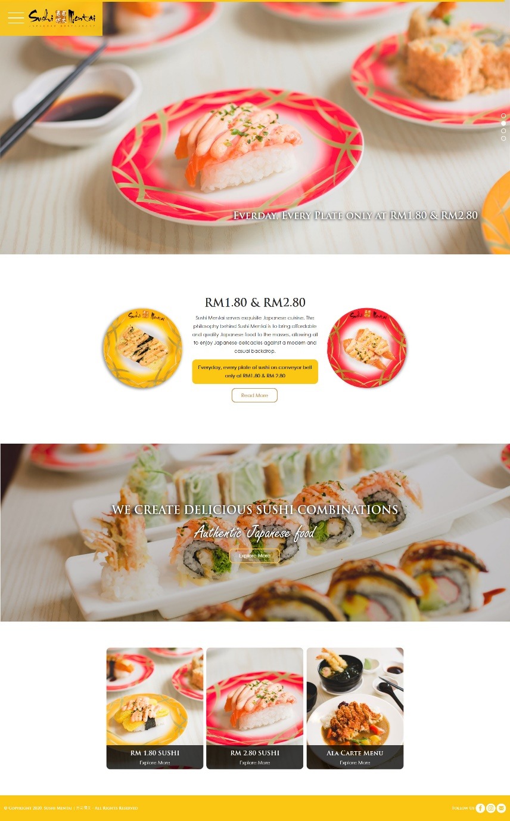

Figure 5: Screenshot of Sushi Mentai website

Sushi Mentai website offers a refreshing and enticing look, where the colors used complement the food pictures well and attracts your attention. It is not reflected in the still screenshot, but certain elements of the website have animation, such as pop-up effect, slight rotation when hovering over, fly-in effect and more. It also has a responsive design on both tablets and phones.

Despite the beautiful and appealing interface, the website does not offer many functionalities. It has the basic functionalities such as menu display, outlets display, career display and company information. Sushi Mentai offers lucky draw and customers can join the mentioned lucky draw through online. After clicking the button to join, it redirects you to a google form, where you can fill in your details. The Japanese restaurant is no longer accepting franchisees so we are not sure whether you can apply for franchise through online or not.

|  |  |  |  |  |
| --- | --- | --- | --- | --- |
| **Features** | **Sakae Sushi** | **Rakuzen** | **Sushi Zanmai** | **Sushi Mentai** |
| 1. Attractive design  (layout, color theme) | ✘ | ✘ | ✘ | ✔ |
| 2. Responsive design | ✘ | ✔ | ✘ | ✔ |
| 3. Profile management  (registration, login) | ✔ | ✘ | ✘ | ✘ |
| 4. Membership application | ✘ | Not offered | Not offered | Not offered |
| 5. Franchise application | ✘ | ✘ | ✔ | Closed |
| 6. Lucky draw application | ✘ | ✘ | ✘ | ✔ |
| 7. Information display  (menu, outlet location, company information, careers, promotions) | ✔ (Missing Menu) | ✔  (Missing Promotion) | ✔  (Missing outlets) | ✔ |
| 8. Food delivery | ✔  (Different website) | ✘ | ✘ | ✘ |
| 9. Order pick-up | ✘ | ✘ | ✘ | ✘ |
| 10. Reservation booking | ✘ | ✘ | ✘ | ✘ |

Table 1: Summary of website analysis

## Use-case diagram

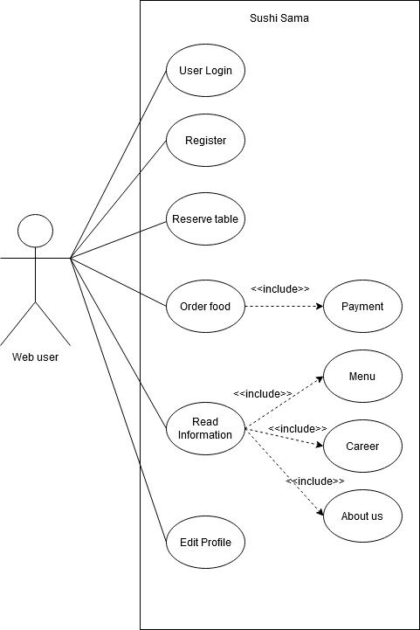

Diagram 1: UCD Diagram for users

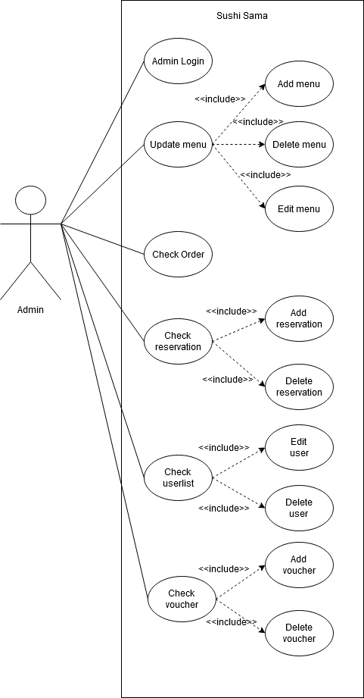

Diagram 2: UCD Diagram for admins

## Distribution of development / coding tasks

|  |  |  |  |  |  |
| --- | --- | --- | --- | --- | --- |
| **Tasks** | **Kar Sing** | **Guan Cheng** | **Yuan Jun** | **Michelle** | **Lucas** |
| Website design (navigational flow, layout, color palette, etc.) |  | ✔ |  | ✔ | ✔ |
| Homepage and other information display |  |  |  | ✔ | ✔ |
| Table reservation |  |  | ✔ | ✔ |  |
| Profile management (login/register) | ✔ | ✔ |  |  | ✔ |
| Menu display/ Menu selection |  |  |  | ✔ |  |
| Order summary |  | ✔ |  |  |  |
| Discount calculation | ✔ |  | ✔ |  |  |
| Payment processing | ✔ |  | ✔ |  |  |
| Admin – Login | ✔ |  |  |  | ✔ |
| Admin – Menu update |  |  |  | ✔ | ✔ |
| Admin – User List |  |  |  |  | ✔ |
| Admin – Check order | ✔ |  |  |  |  |
| Admin – Check reservation | ✔ |  |  | ✔ |  |
| Documentation | ✔ | ✔ | ✔ | ✔ | ✔ |

Table 2: Distribution of tasks

# Implementation

## HTML

#### Description of elements used

We have used several HTML elements such as container, card, tables, navbar, custom form, where certain elements are only available thanks to the Bootstrap framework.

For every page, we use a combination of container, row and different sizes of column to create the multicolumn layout that will resize and fit automatically in response to different device width through the Bootstrap framework, which allows a simple process of creating responsive design.

Our menu includes the usage of bootstrap cards, which provide flexible and extensible content containers since the cards support a wide variety of content including the images, text and more.

We use bootstrap table to create our order summary because working with the bootstrap framework, we can easily improve the appearance of the table so that the user can have a greater experience.

The table reservation is made through a form so that we can receive information when the user submits. Forms are also used in many areas so that we can data can be stored in the superglobal array and then be processed in our PHP script.

We also use Bootstrap modals for seeking for confirmation of actions, for asking details to insert new data or to edit the existing data.

#### Navigational flow design

A navigation bar is located top of our website, it links users to home, menu, order, career, profile and login. Since the navigation is generally the direction that takes the users where they want to go, setting it at the top allows user to navigate through our website quickly and easily.

Our utility navigation, i.e. user login is on top of the website also. This allow us to have a user-friendly navigation and user will interact with the site because they are able to perform the actions at the first moment. Meanwhile, our website has a page exclusive for admin login which can redirect to Sushi Sama Panel. Inside the Panel, we have order summary, table reservation, menu list, and user list as well.

We have Call to Action (CTA) function for the table reservation, which users will automatically notice once they enter our homepage. Clicking it redirects users to the table reservation form at the bottom of homepage.

Our footer also provides some navigation so users can click on them when they reach the bottom of the page, without the need to scroll up to reach the nav bar.

#### Any tools used?

We used Bootstrap framework because it speeds up our website design process, and it is also compatible with all modern browsers.

We also used font awesome for the various icons displayed in our pages.

Google fonts are used to apply more font-family that suits the web pages.

## CSS

### Description of CSS styles

CSS stands for Cascading Style Sheet which used for describing the presentation how HTML are displayed in the screen.

We have used several elements such as font family, font-weight, font-size to improve the appearance of the font. For the background of the page, images and linear gradient are used to bring out the eye-catching design for users. Also, the images allow us to give certain ideas to the users about what our website must present.

By using media query and the elements of bootstrap such as grids function and collapse, these allow us to adapt the presentation to different types of devices such as size-adapting, and easier for both parties as in developers’ stand and most importantly, users’ stand.

### Responsive design?

Bootstrap allows us to split the website into grids of columns and rows. Based on the device’s width, these columns will arrange themselves appropriately. For certain cases, we also specify the properties of certain elements that we would like to display differently as opposed to the predefined rules, by using the @media notation.

### Any tools used?

Just as explained under 3.1.3, we used Bootstrap framework because it is one of the most popular HTML, CSS and Javascript framework directed at responsive, mobile-first web development.

Our group has also used the material design for bootstrap for (MDBootstrap), where it provides many user interface (UI) elements, such as animation, icons, plugins.

## Client-Side Script

### Description of Script Usage

Javascript is used for client-side script, where it is mainly used for manipulation of data of our HTML. JQuery is used to pass the value of the respective data’s unique ID to the bootstrap modal, which seeks for confirmation when manipulating data on the admin side. Other than that, alert and prompt are also used.

**Examples of jQuery usage:**

To make our navbar attached to the top after scrolling down, we used the jQuery displayed below, where the class ‘scrolled’ is applied to the element with the class ‘navbar-fixed-top’ after scrolling more than the navbar’s height.

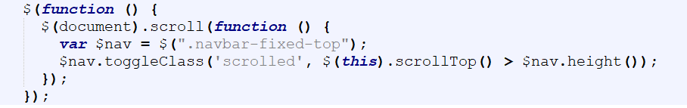

If an admin wants to delete data from the database, they must click on the delete button and a modal will pop up asking for confirmation. The following jQuery will pass the item of deletion to that modal, which allows the data to be sent to the backend side (our PHP code) for processing.

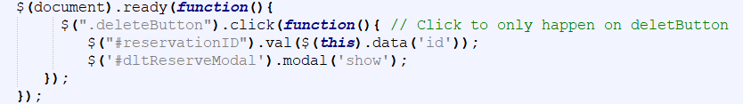

If an admin wants to edit data from the database, they must click on the edit button and a modal will pop up, displaying the current information for that specific item. The following jQuery obtains the information and displays it, which allows admin to easily edit the data.

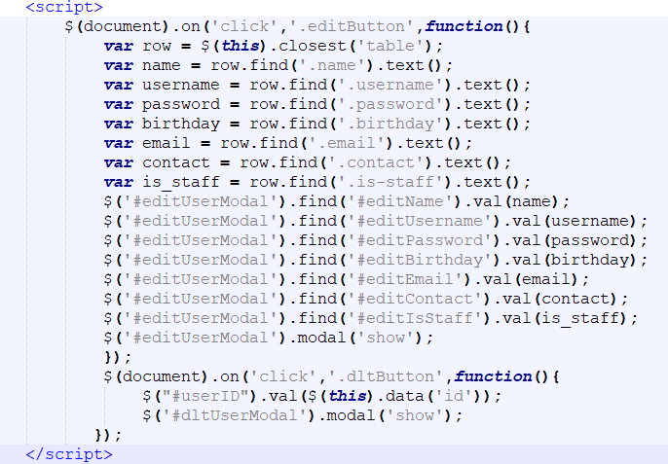

### Any tools used?

No tools are used for Javascript.

## Server-Side Script

### Description of Script Usage

PHP is used for the server-side script. For manipulation of data regarding displaying information, editing information and deleting information from our database, we use PHP to connect to our database through mysqli statements. Data from form are obtained through super global array, $_POST, where they are then stored in our SQL database. PDO statements are used to retrieve the data from our SQL database for display of information and deletion of information.

**Examples of PHP usage:**

To read data from our database and display the data on our website, we use PDO statements (as learned from our Labs). The example given below is on menu items.

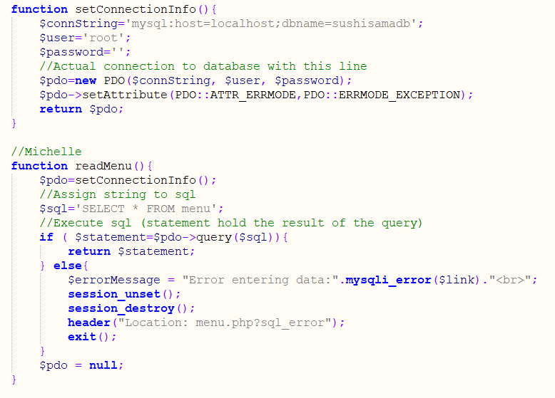

From our frontend files, we use the readMenu function to obtain all the data and echo the data we need.

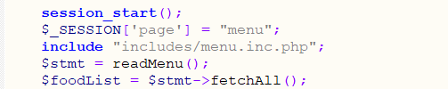

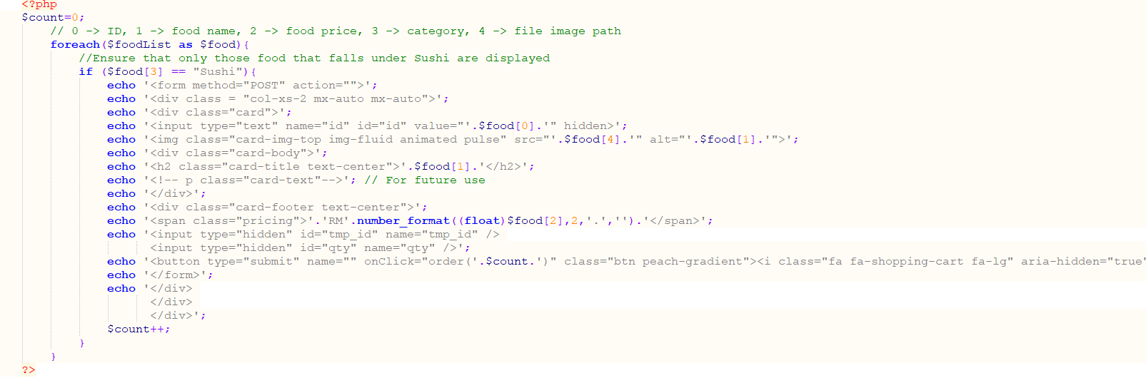

Deletion of data from our database is handled similarly to the display of data, where PDO statements are used. The example given is on Menu items as well.

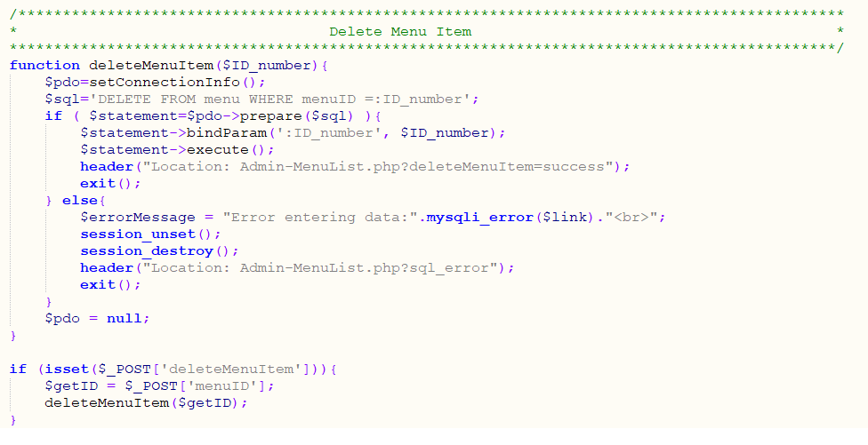

We also use sqli statements to edit our data or insert new data to our database. The following codes are on Menu items as well.

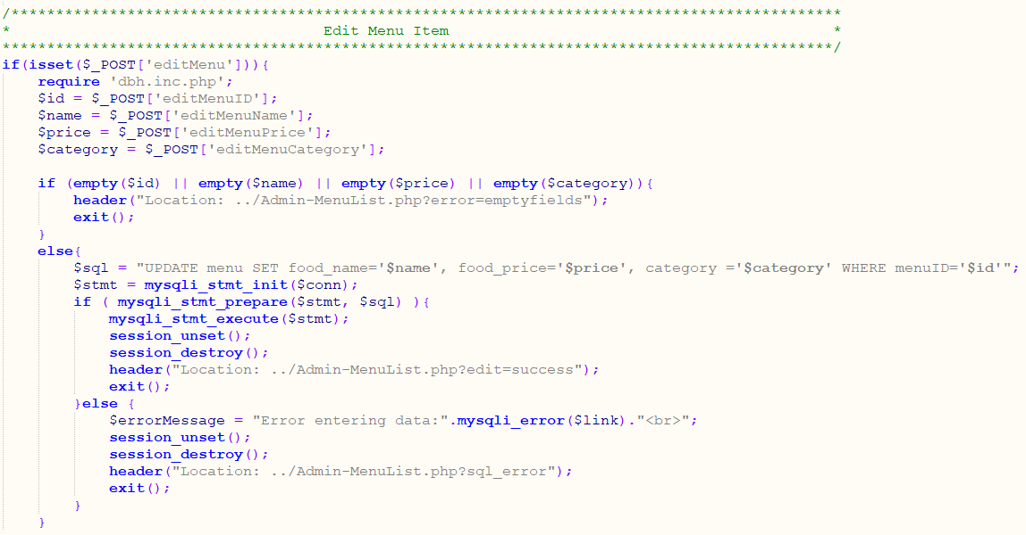

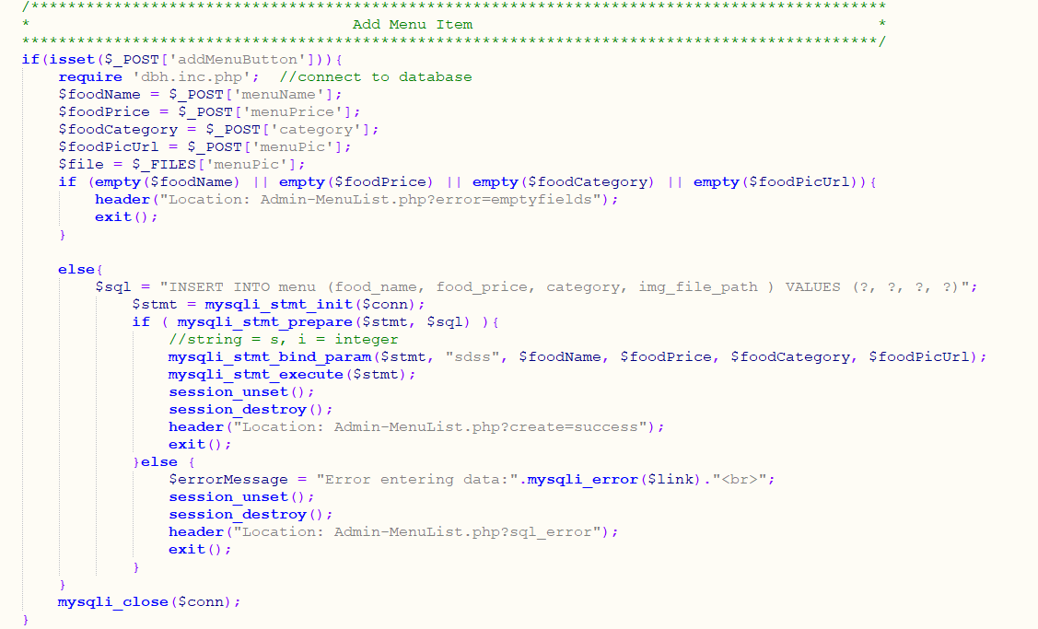

### Any tools used?

We used XAMPP as our PHP development environment, where it runs a web server and a database.

## Database

### Description of Database

MySQL is used for our database, where we create multiple tables to store our data such as Menu, Reservation, User details, Payment, Payment Detail, Promo (vouchers) and Credit Card. Examples of MySQL statements for table creation and data insertion are as below:

|  |  |
| --- | --- |
| **Table** | **MySQL Statements** |
| Credit Card | CREATE TABLE `credit_card` (  `card_id` int(255) NOT NULL,  `card_name` varchar(255) COLLATE utf8_bin NOT NULL,  `card_num` varchar(20) COLLATE utf8_bin NOT NULL,  `card_exp` varchar(20) COLLATE utf8_bin NOT NULL,  `card_code` varchar(20) COLLATE utf8_bin NOT NULL,  `card_country` varchar(50) COLLATE utf8_bin NOT NULL,  `card_ref` varchar(100) COLLATE utf8_bin NOT NULL,  `card_payment` float NOT NULL,  `payment_id` int(11) NOT NULL  )  INSERT INTO `credit_card` (`card_id`, `card_name`, `card_num`, `card_exp`, `card_code`, `card_country`, `card_ref`, `card_payment`, `payment_id`) VALUES  (1, 'Loo Yuan Jun', '5196032041483065', '12/31', '123', 'Malaysia', '20200218-100001', 6.16, 9); |
| Menu | CREATE TABLE `menu` (  `menuID` int(255) NOT NULL,  `food_name` varchar(255) DEFAULT NULL,  `food_price` float DEFAULT NULL,  `category` varchar(60) DEFAULT NULL,  `img_file_path` varchar(200) DEFAULT NULL  )  INSERT INTO `menu` (`menuID`, `food_name`, `food_price`, `category`, `img_file_path`) VALUES  (1, 'Salmon Sushi', 4.8, 'Sushi', 'images/menu/salmon_sushi.jpg'); |
| Payment | CREATE TABLE `payment` (  `payment_id` int(11) NOT NULL,  `payment_total` float NOT NULL,  `payment_tax` float NOT NULL,  `promo_code` varchar(255) COLLATE utf8_bin DEFAULT NULL,  `promo_type` varchar(255) COLLATE utf8_bin DEFAULT NULL,  `payment_discount` float NOT NULL DEFAULT 0,  `payment_grand` float NOT NULL,  `payment_paid` float NOT NULL,  `payment_change` float NOT NULL,  `payment_time` timestamp NOT NULL DEFAULT current_timestamp(),  `payment_type` varchar(255) COLLATE utf8_bin NOT NULL DEFAULT '0',  `remark` varchar(1000) COLLATE utf8_bin NOT NULL DEFAULT '0',  `username` varchar(255) COLLATE utf8_bin NOT NULL  )  INSERT INTO `payment` (`payment_id`, `payment_total`, `payment_tax`, `promo_code`, `promo_type`, `payment_discount`, `payment_grand`, `payment_paid`, `payment_change`, `payment_time`, `payment_type`, `remark`, `username`) VALUES  (1, 8.4, 0.84, 'PROMO12', 'PERCENT', 1.01, 8.23, 0, 0, '2020-02-18 13:14:18', '', '', '8'); |
| Payment Detail | CREATE TABLE `payment_detail` (  `detail_id` int(11) NOT NULL,  `menuID` int(255) NOT NULL,  `food_name` varchar(255) COLLATE utf8_bin NOT NULL,  `food_price` float NOT NULL,  `food_qty` int(10) NOT NULL,  `category` varchar(60) COLLATE utf8_bin NOT NULL,  `img_file_path` varchar(200) COLLATE utf8_bin NOT NULL,  `payment_id` int(11) NOT NULL  )  INSERT INTO `payment_detail` (`detail_id`, `menuID`, `food_name`, `food_price`, `food_qty`, `category`, `img_file_path`, `payment_id`) VALUES  (1, 2, 'California roll', 2.8, 3, 'Sushi', 'images/menu/california-rol.jpg', 5); |
| Promo | CREATE TABLE `promo` (  `promo_code` varchar(255) COLLATE utf8_bin NOT NULL,  `promo_type` varchar(255) COLLATE utf8_bin NOT NULL,  `promo_price` float NOT NULL,  `promo_active` tinyint(4) NOT NULL  )  INSERT INTO `promo` (`promo_code`, `promo_type`, `promo_price`, `promo_active`) VALUES  ('DISCOUNT12', 'CASH', 12, 1); |
| User | CREATE TABLE `user` (  `id` int(11) NOT NULL,  `username` tinytext NOT NULL,  `password` longtext NOT NULL,  `email` tinytext NOT NULL,  `name` varchar(255) DEFAULT NULL,  `birthday` date DEFAULT NULL,  `contact` varchar(13) NOT NULL,  `is_admin` tinyint(1) NOT NULL  )  INSERT INTO `user` (`id`, `username`, `password`, `email`, `name`, `birthday`, `contact`, `is_admin`) VALUES  (1, 'test', '123', 'test123@mmu.edu.my', 'I am testing', '2020-02-02', '012-345 6789', 1); |
| Reservation | CREATE TABLE `reservation` (  `reservationID` int(155) NOT NULL,  `date_of_reservation` date DEFAULT NULL,  `time_of_reservation` time DEFAULT NULL,  `num_of_adult` int(11) DEFAULT NULL,  `num_of_child` int(11) DEFAULT NULL,  `full_name` varchar(100) DEFAULT NULL,  `email` varchar(50) DEFAULT NULL,  `phone` varchar(20) DEFAULT NULL,  `city` varchar(20) DEFAULT NULL,  `special_remarks` varchar(300) DEFAULT NULL  )  INSERT INTO `reservation` (`reservationID`, `date_of_reservation`, `time_of_reservation`, `num_of_adult`, `num_of_child`, `full_name`, `email`, `phone`, `city`, `special_remarks`) VALUES  (1, '2012-12-10', '10:00:00', 1, 0, 'Michelle Chai', 'test', '0165727809', 'test', 'testtest' ); |

### Any tools used?

Through XAMPP, we can look and manipulate the data in our database through phpMyAdmin, where we can drop tables, delete a record (row in the table), edit the structures of our table, insert new data and more.

## Final product

## Instruction Manual

**For user:**

1. Once the website in launched, home page will be shown.

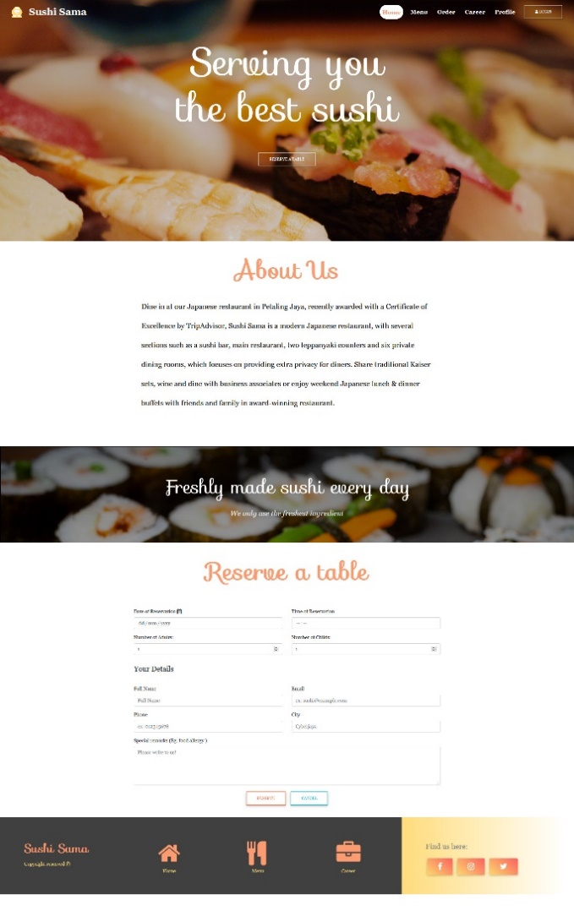

Figure 6: Home page

1. Click Sign Up to register a new account, if account is registered, click login button on the navigation bar to login by entering username and password. Login is required for payment after order is made.

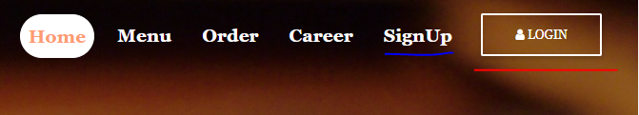

Figure 7: Navigation Bar

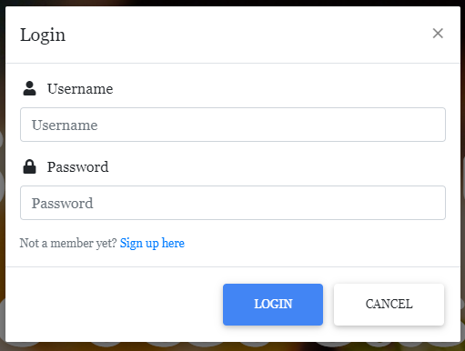

Figure 8: Login Popup

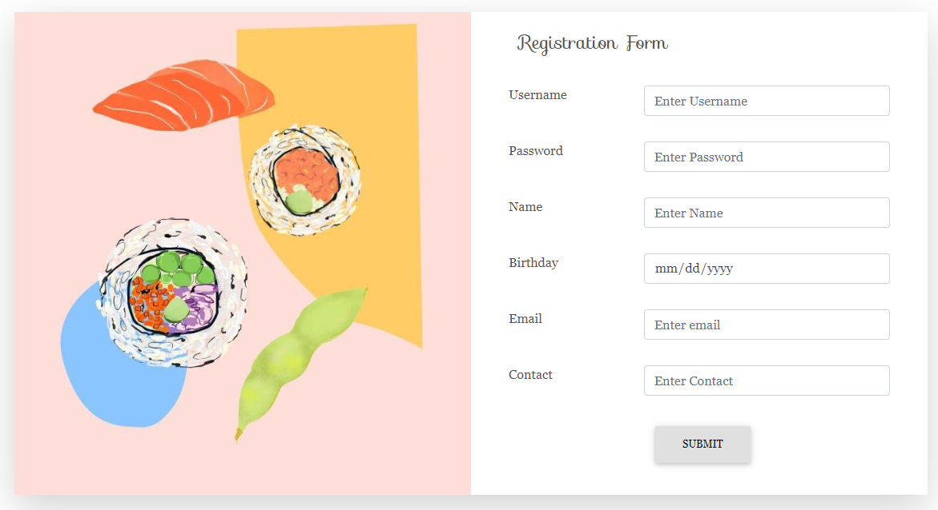

Figure 9: Registration Page

1. Reservation can be made in home page, which can be seen after scrolling down, successful reservation is made upon entering valid detail and clicking the ‘Reserve’ button.

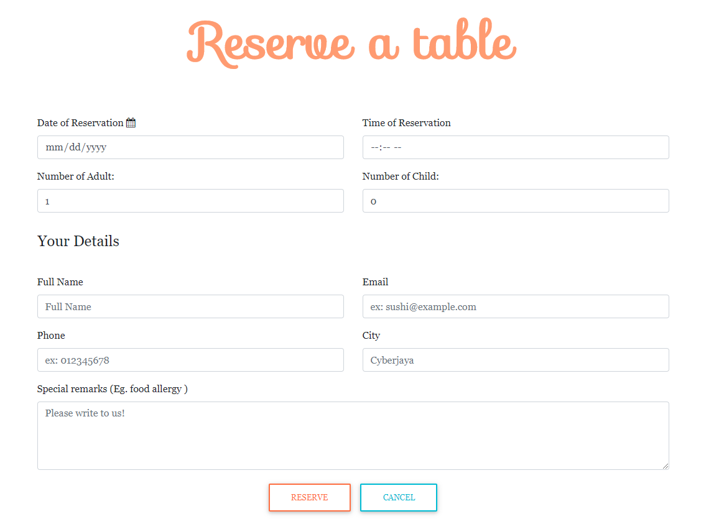

Figure 10: Reservation Form at home page

1. From home page, user can navigate to menu, career, order. After logged in, user can navigate to profile page.

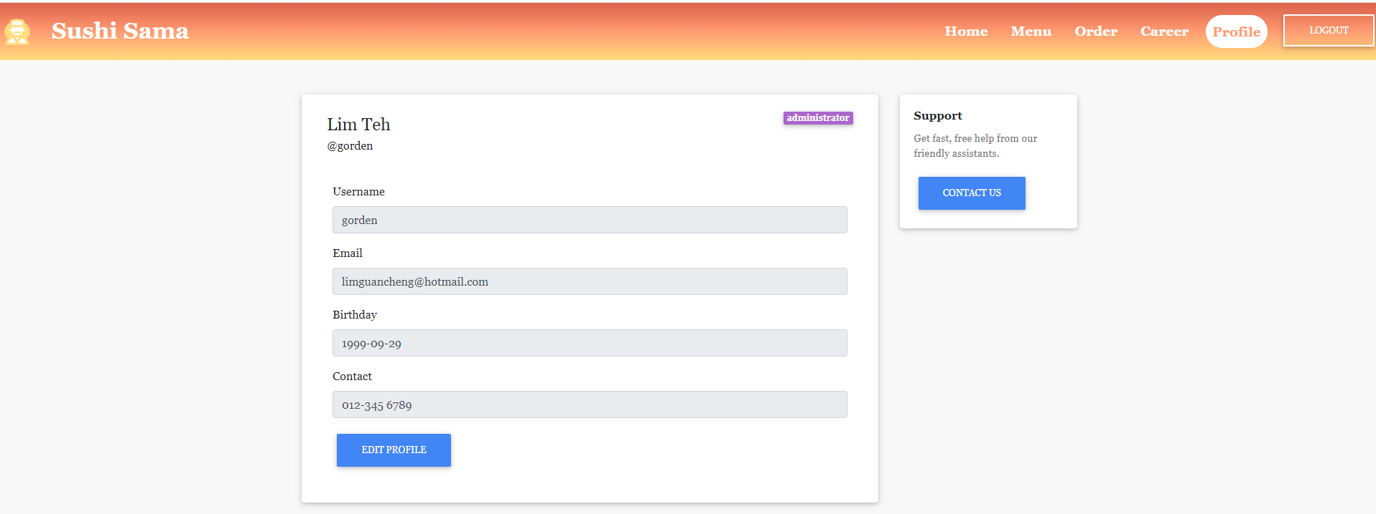

Figure 11: Profile page

1. User can edit profile by clicking edit profile button. User will be redirected to edit profile page for change of detail.

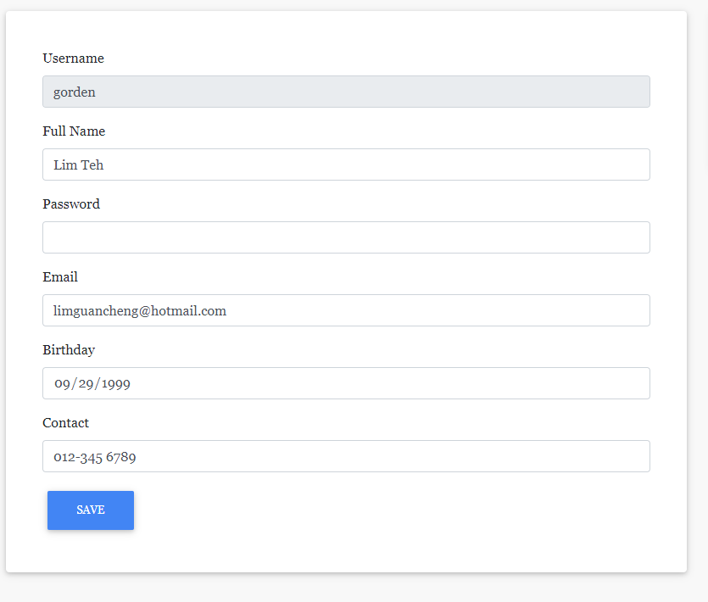

Figure 12: Edit profile page

1. Order can be made in menu page. By clicking cart button on specific dish, user will be prompted to enter quantity for the item to be passed to order. After submitting the quantity, menu page will be refresh and allow user to add more food into the order.

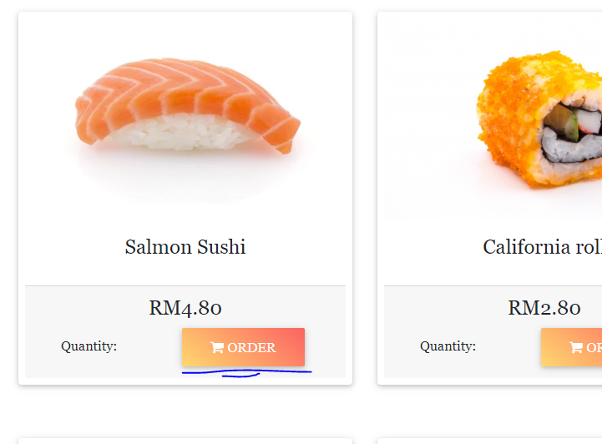

Figure 13: Menu item card

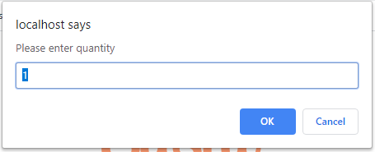

Figure 14: Prompt to enter meal quantity

1. After finish order, user can navigate to order page from the navigation bar. User can enter promo code that is active to apply for discount on total price. User can enter special remarks for their orders. After that, user may proceed to check out

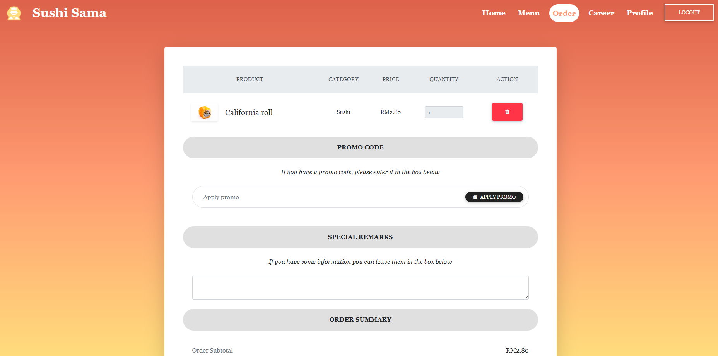

Figure 15: Order page

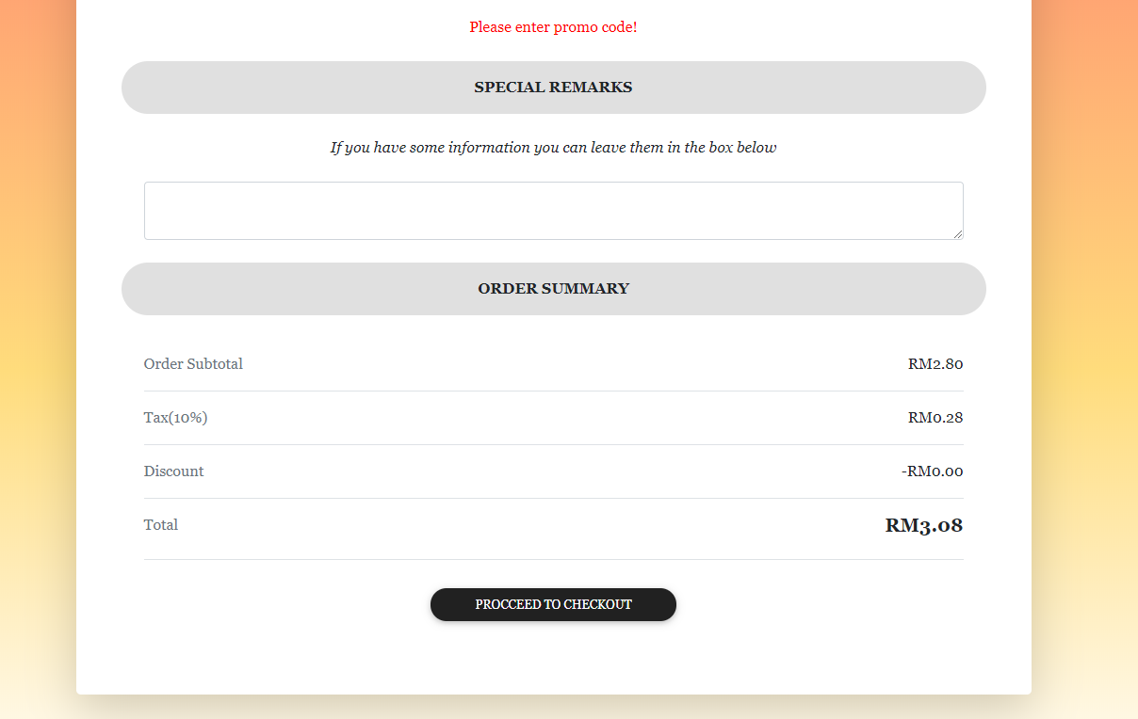

Figure 16: Order page’s order summary

1. After proceeding to checkout is clicked, user will be redirect to payment page, user can select cash payment or credit card payment. After entering amount bigger than total price, payment successful will be shown for cash payment. While for card payment, user will be direct to card page.

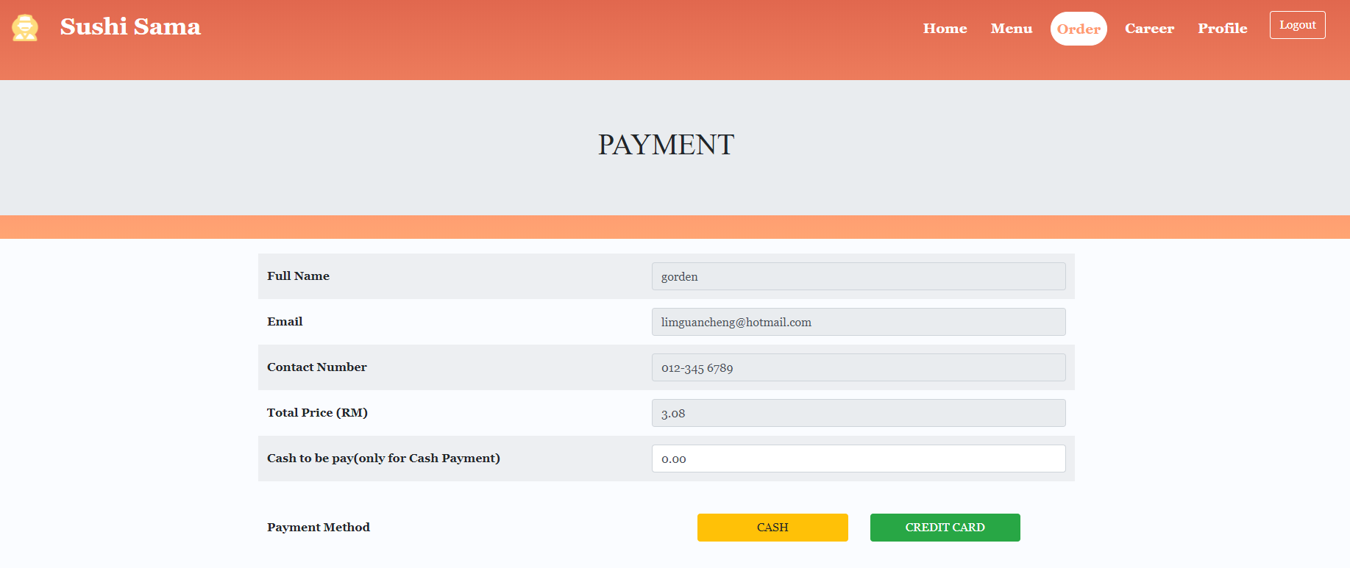

Figure 17: Payment page

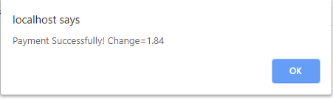

Figure 18: Cash payment successful message

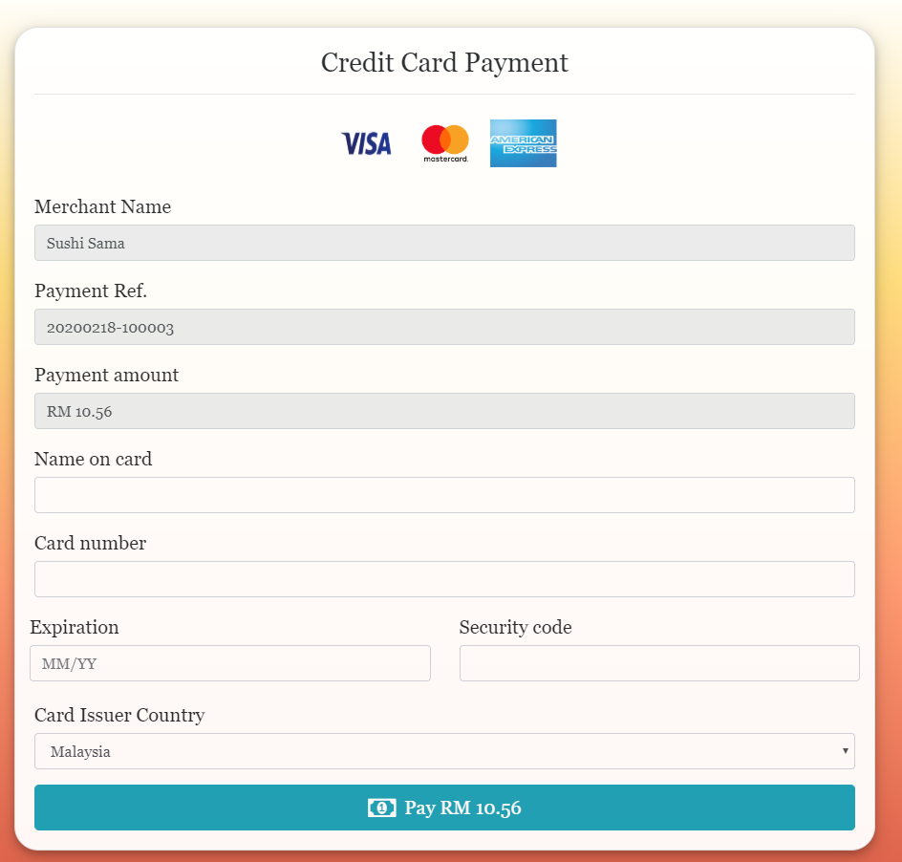

Figure 19: Credit card payment page

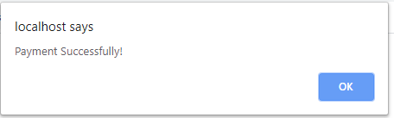

Figure 20: Credit card payment successful message

1. Besides, user can navigate to career page to see the detail of recruitment.

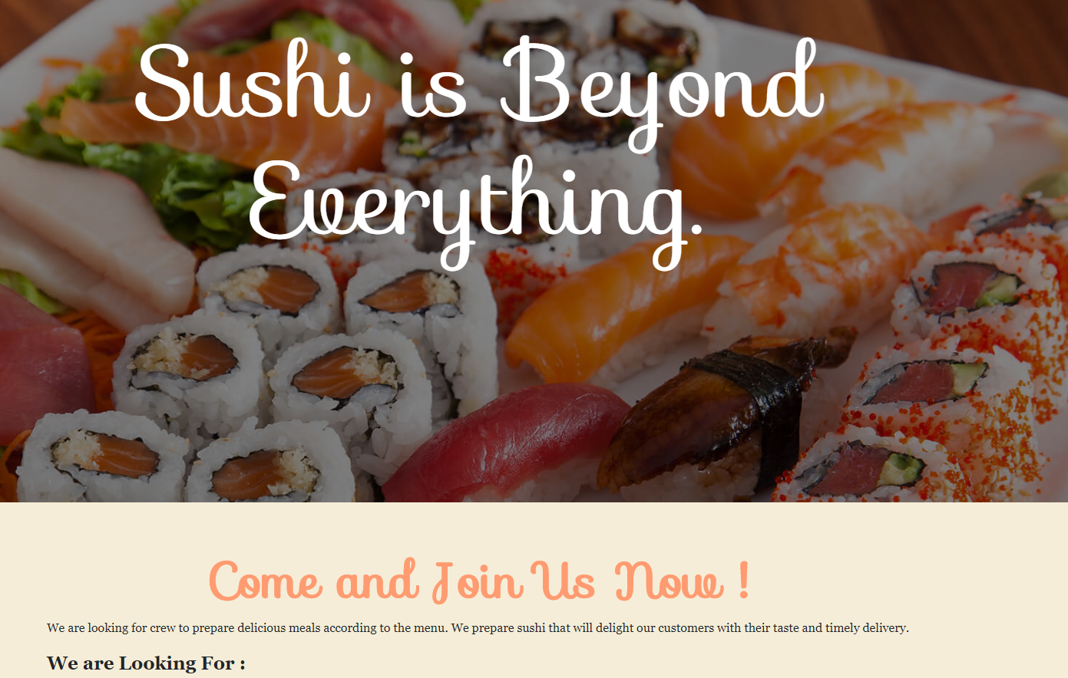

Figure 21: Career Page

**For admin:**

1. To access admin page, admin need to login from the login page by entering valid credential.

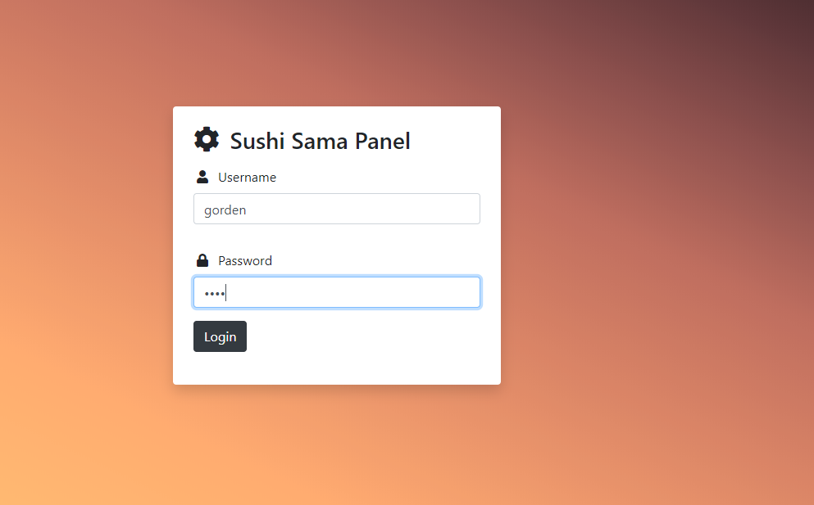

Figure 22: Admin login page

1. After logged in, admin can click on either one of the five buttons to check the details for respective tables such as order summary, table reservation list and so on. Admin can log out by clicking the logout button at the top right corner of the navigation bar from any of the pages.

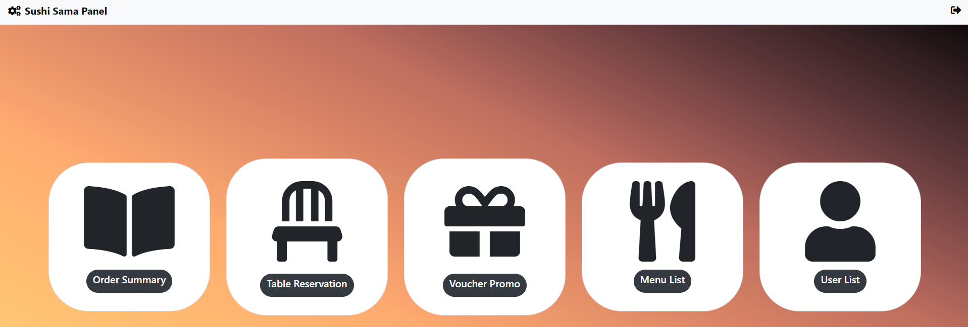

Figure 23: Admin Homepage

1. At order summary page, admin can check the order and payment made by user, admin can also remove the order by clicking the trash bin button. A modal will appear for delete confirmation. Admin can also check the detail of the order by clicking the info button.

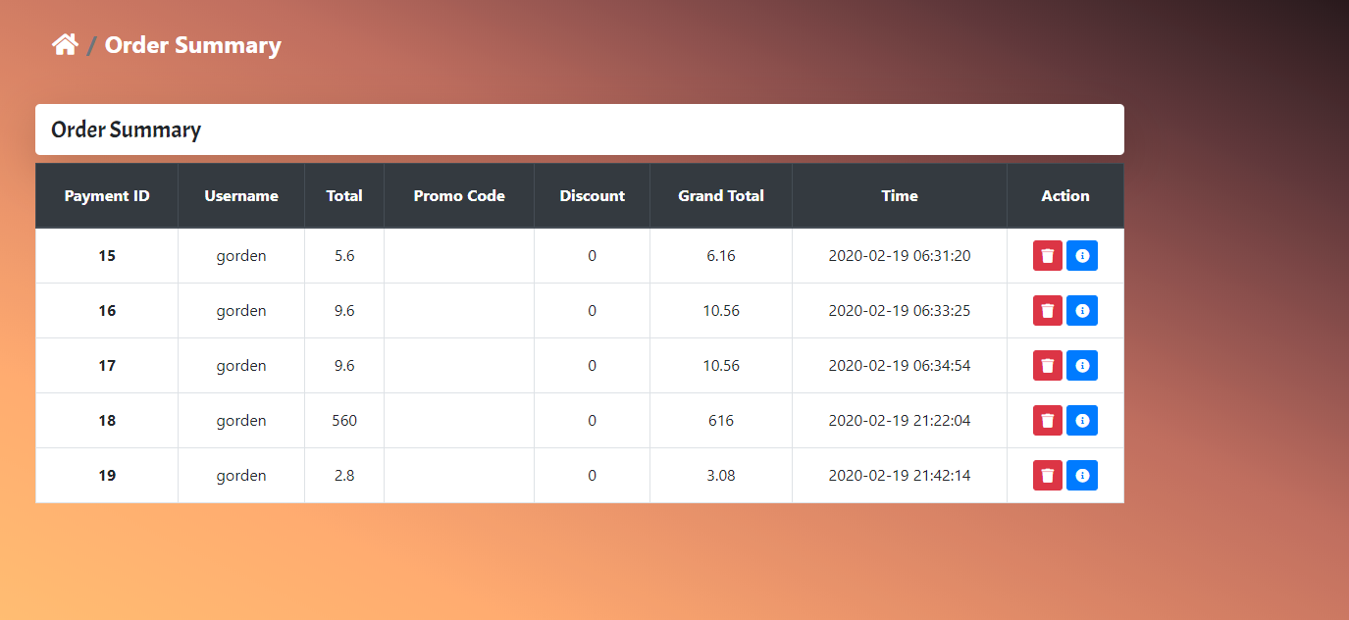

Figure 24: Order Summary Page

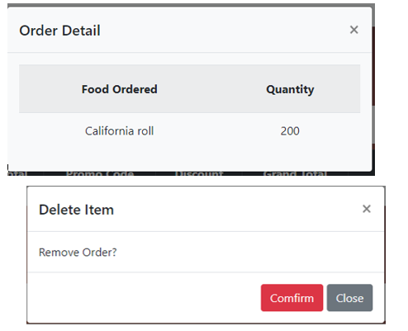

Figure 25: Modals for order

1. To navigate back to admin homepage, admin can click the house icon.

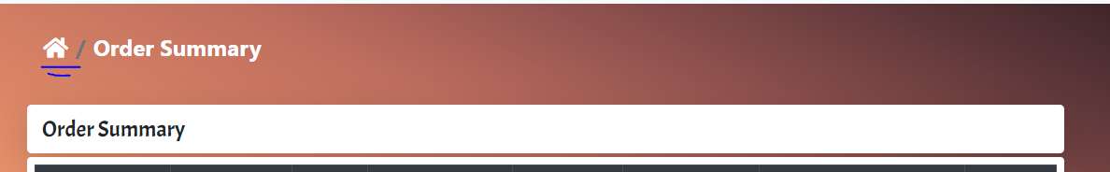

Figure 26: Breadcrumb to navigate to admin homepage

1. For table reservation list, admin can add, edit and delete reservation made by customers. By clicking respective button, a modal will be shown to perform the action.

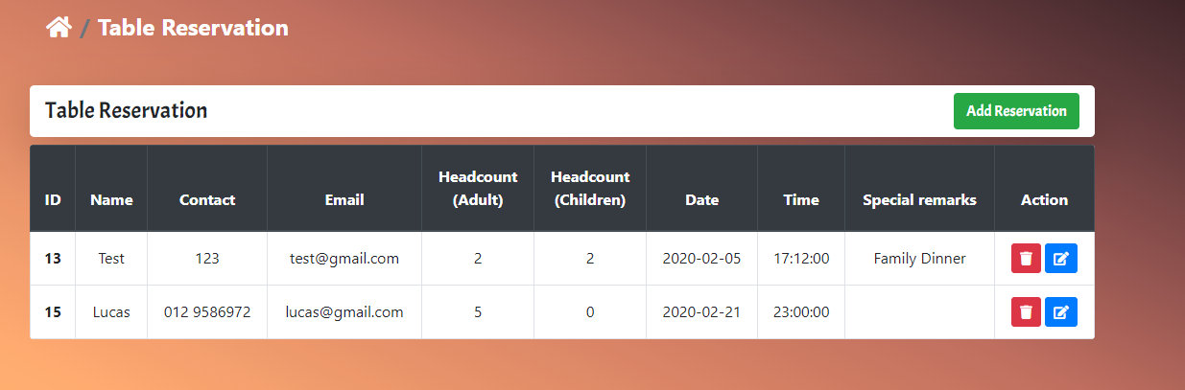

Figure 27: Table reservation list

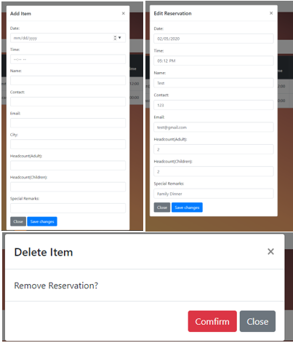

Figure 28: Modals for reservation

1. User can navigate to voucher page to add and remove vouch that is applicable for customer to add discount.

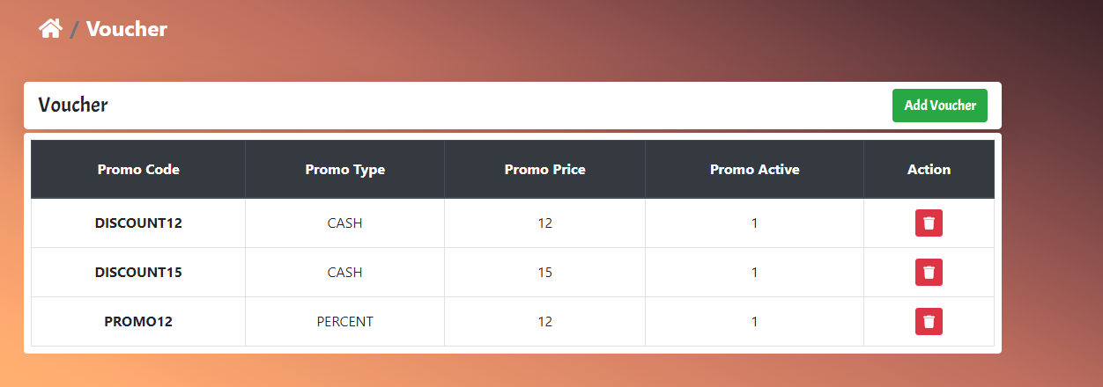

Figure 29: Voucher Table

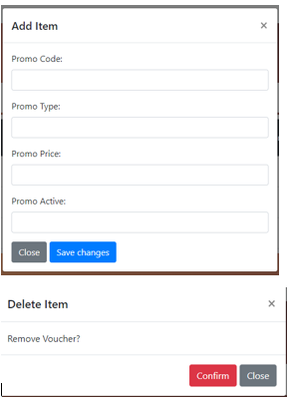

Figure 30: Modals for vouchers

1. Admin can use menu list to manage menu items. Admin can add, edit or delete item from the menu for user to order.

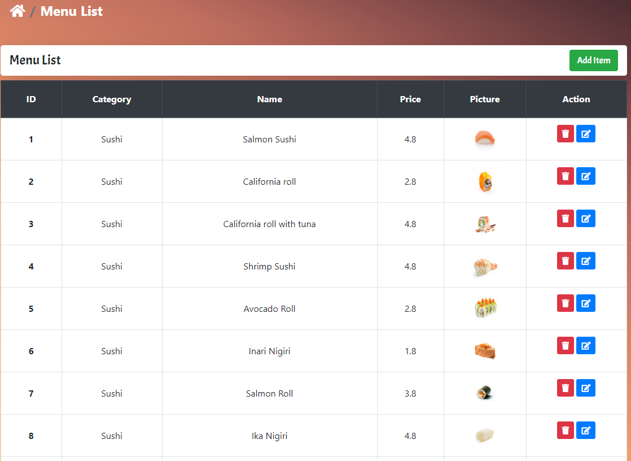

Figure 31: Menu List

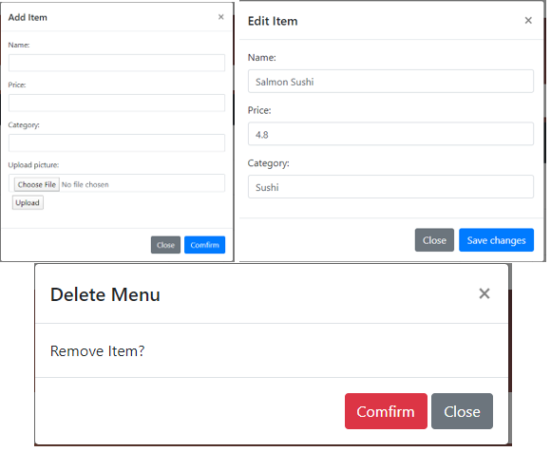

Figure 32: Modals for menu list

1. Admin can use user list to manage user profile and user details. Admin can edit or remove user.

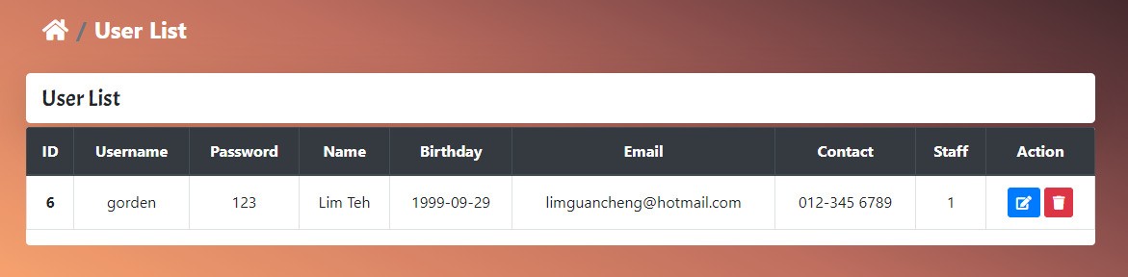

Figure 33: User List

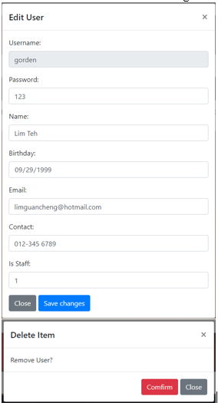

Figure 34: Modal for User List

## Screenshots

 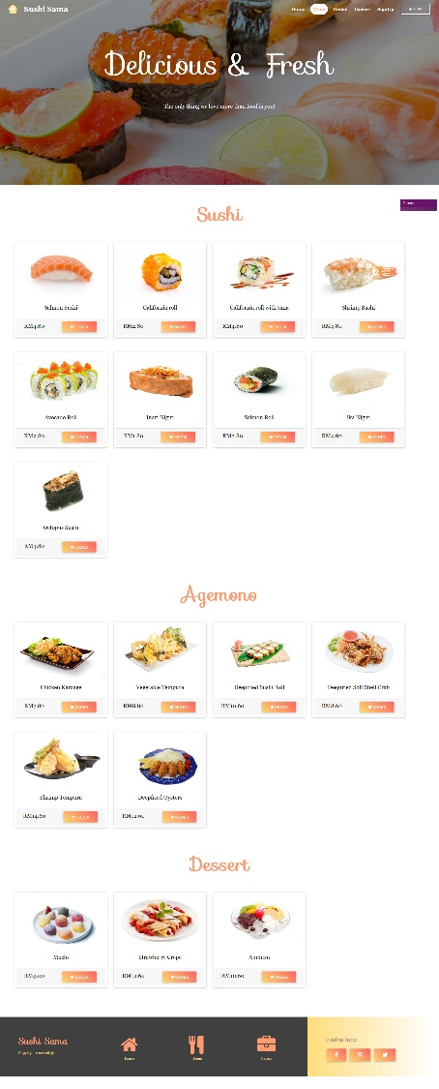

Figure 35: Homepage (home.php) Figure 36: Menu (menu.php)

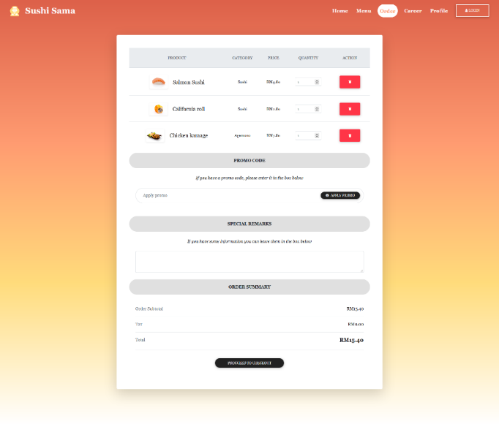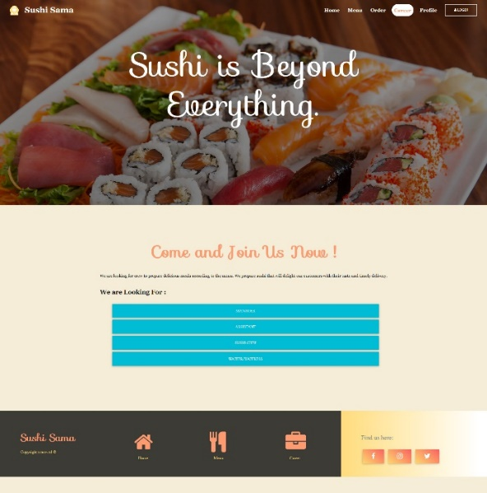

Figure 37: Order summary (order.php) Figure 38: Career (career.php)

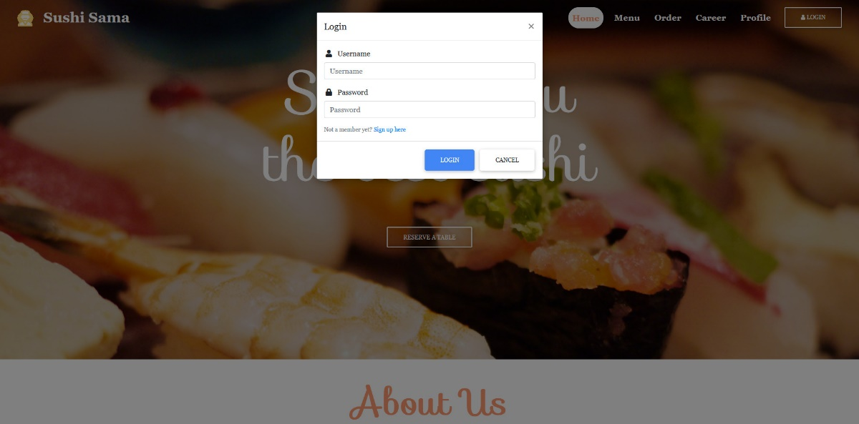

Figure 39: Login modal (pop up)

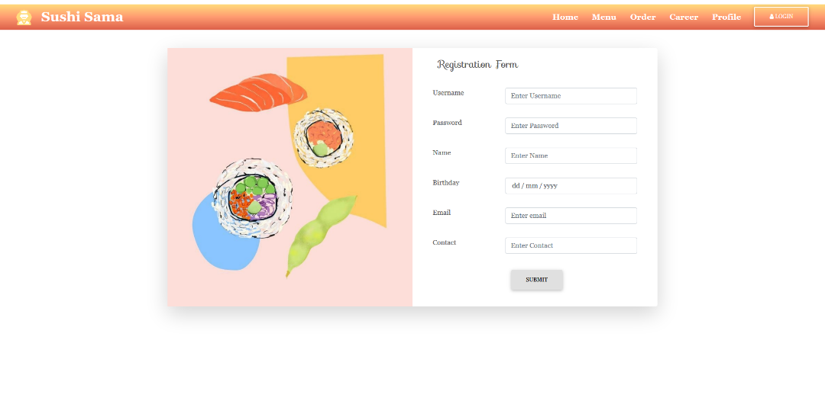

Figure 40: Registration (registration.php)

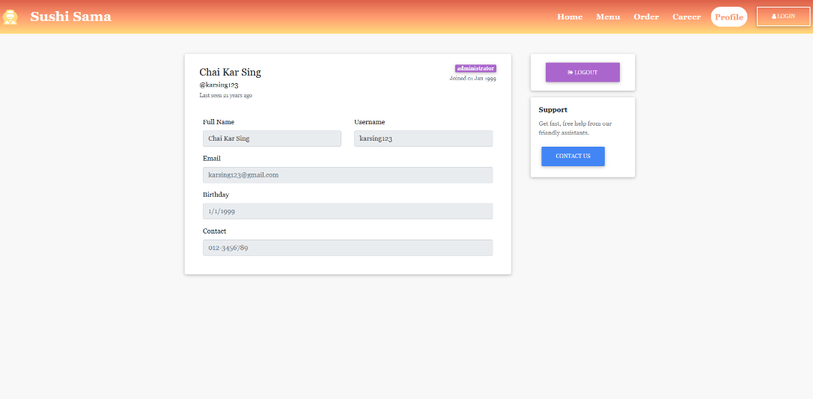

Figure 41: Profile (profile.php)

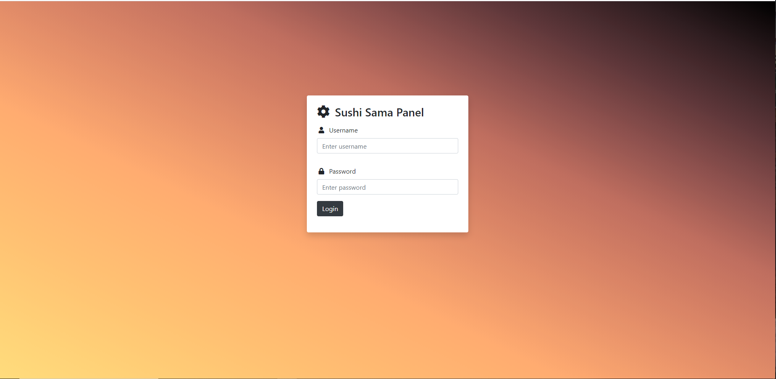

Figure 42: Admin Login (AdminLogin.php)

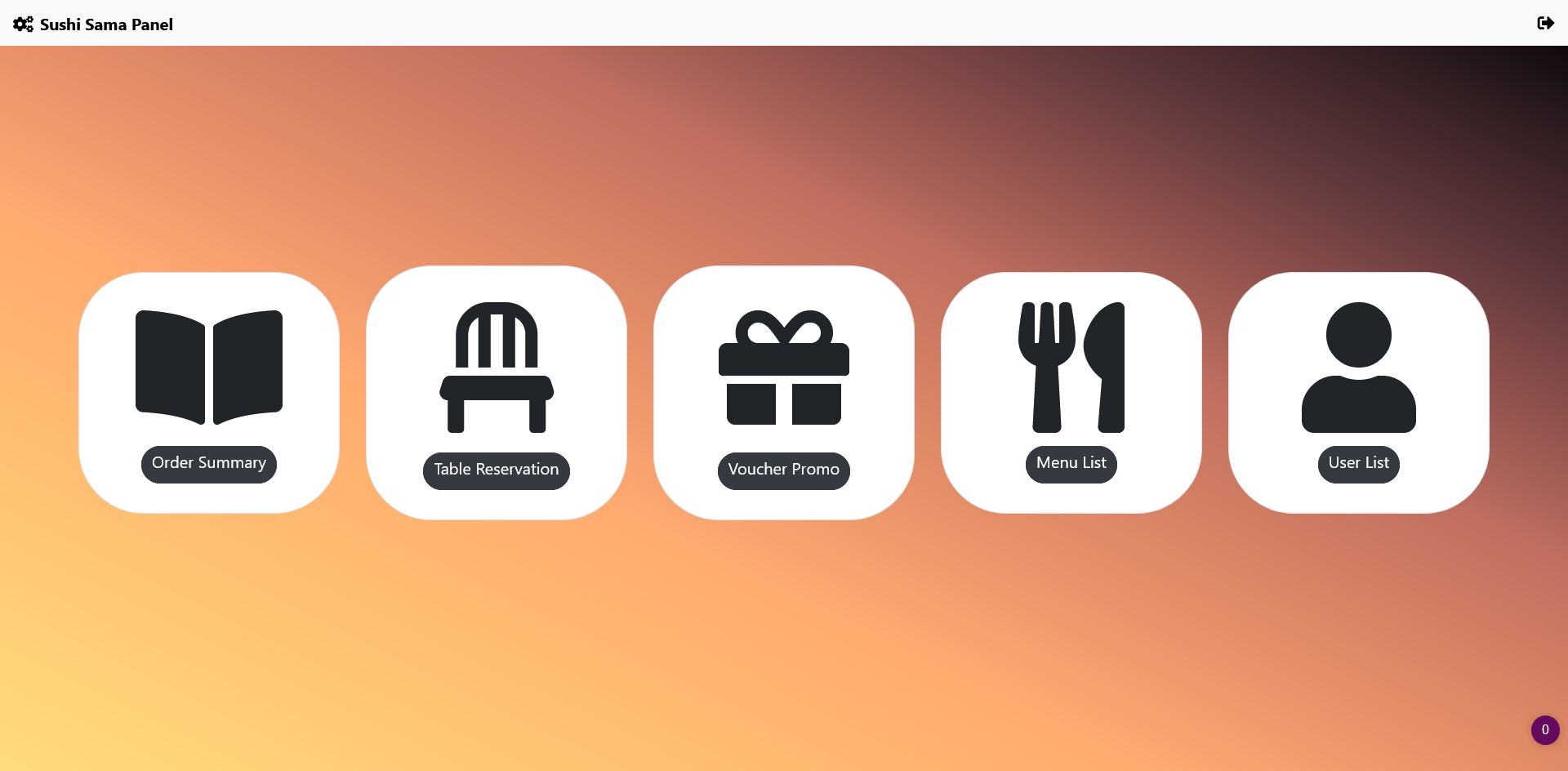

Figure 43: Admin Home (AdminHome.php)

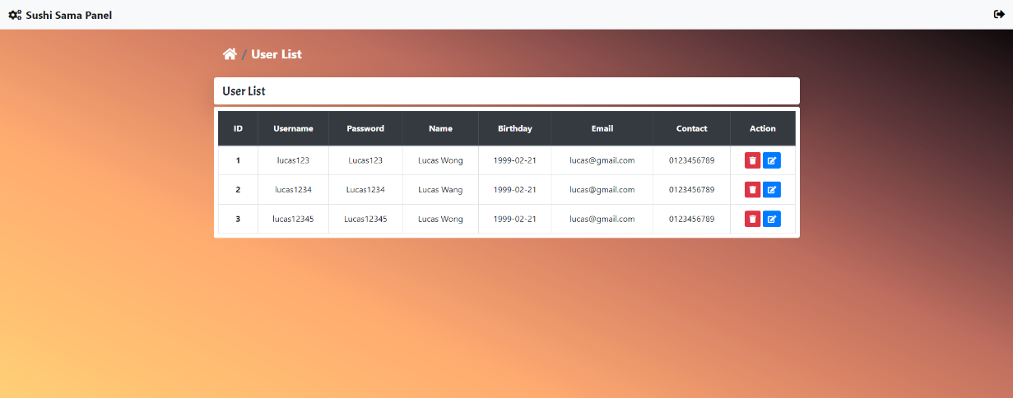

Figure 44: User List (Admin-UserList.php)

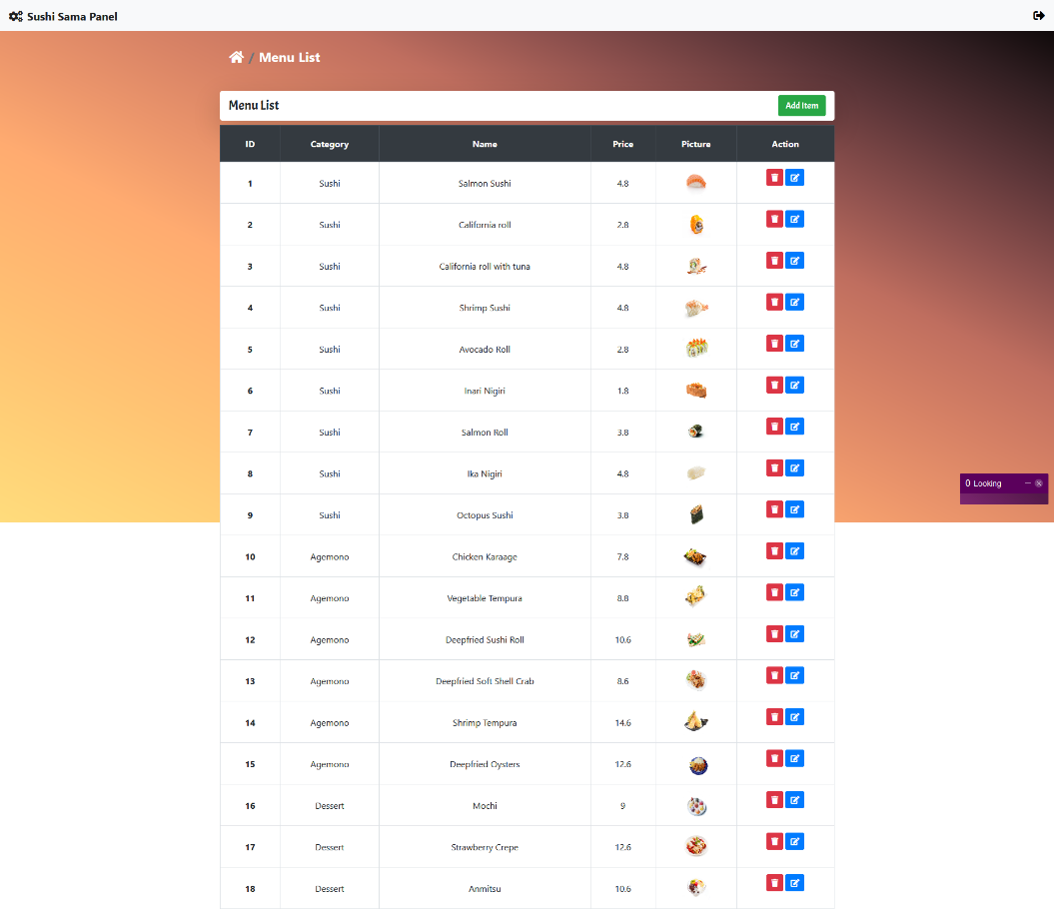

Figure 45: Menu (Admin-MenuList.php)

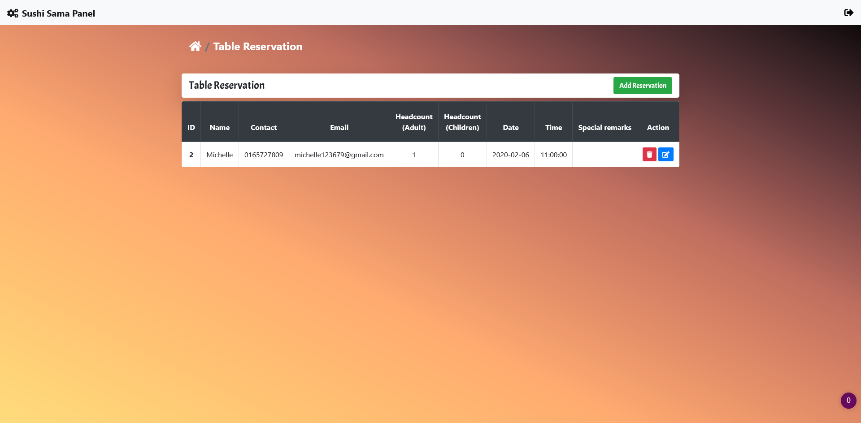

Figure 46: Reservation (Admin-ReservedList.php)

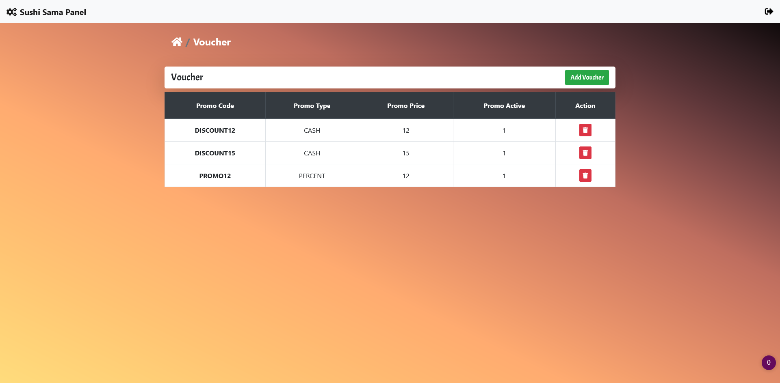

Figure 47: Voucher (Admin-Voucher.php)

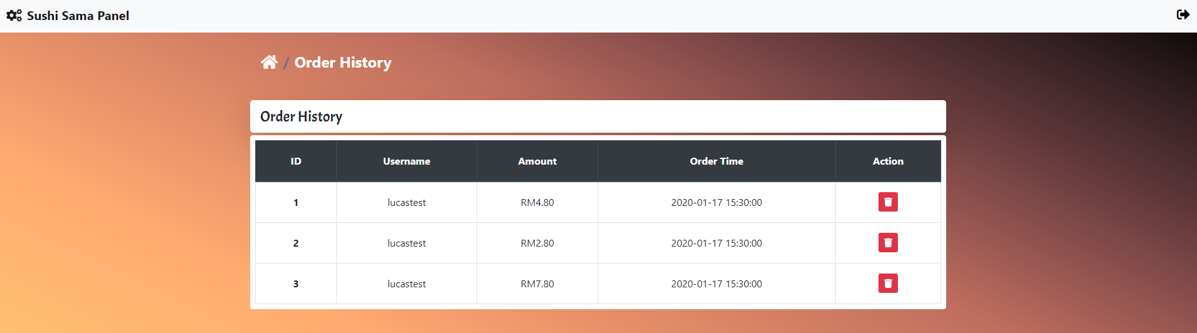

Figure 48: Order History (Admin-OrderSummary.php)

# Limitations and Future Improvements

In terms of functional design, there are more functions we can make for the website such as showing the order history made by user and even provide function for user to repeat their order. Other than that, we can ensure data security through certain encryption, which is currently not implemented for our website. Initially, our passwords for users are encrypted through hash encryption, but it was a one-way encryption; after the encryption, it was too long for us to process at the admin’s side. There is also a lack of validation of input data such as alphanumeric characters check, email validation checks, date of reservation must be after the date of today etc.

Moreover, we can find an online solution for our database such as AWS or Firebase, where manual insertion and update of MySQL tables are unnecessary. This allows everyone who uses the website to have access to the same consolidated data. Currently, we export the data we input and share it among ourselves for all of us to have access to the same set of data.

In terms of design, we would like to make the website more interactive through placing animations that will only be triggered once the user performs certain actions such as scrolling to one section. Furthermore, we would love to make our website more attractive and pleasing to users through both front-end and back-end development.

# Discussion and Conclusion

Websites plays an important role for all types of businesses; it is their face and main front when interacting with customers. The eye-capturing visual effects from dynamic and interactive elements are commonly used on websites. Many of us browse websites to obtain information about certain businesses or their products.

In our Assignment 1, we have learned the basics of building website using HTML and CSS with Bootstrap. We have examined a few different websites, where we did a thorough analysis to identify the strength and weaknesses of each website. All our group members offered different opinion to improve our websites so that it can be more user friendly and attractive. Other than that, we also develop responsive elements for our website so that the webpage can be viewed on mobile phones, tablets, and smaller screens. Mobile phones are commonly used to browse website, so we pay extra attention to the responsiveness of our websites.

For our Assignment 2, we added JavaScript, PHP, and added MySQL database for our website so that we can manipulate the data submitted by the users. Furthermore, we can also add new information, edit existing information or delete information from our website easily through the admin panel. For example, we can use the add button on the admin’s side to add a new menu item by providing food name, food price, food category and uploading the image.

For this website, we aim to achieve better user experience than others website and make our website one of the best in the field.

# Appendix – HTML validation (Assignment 1)

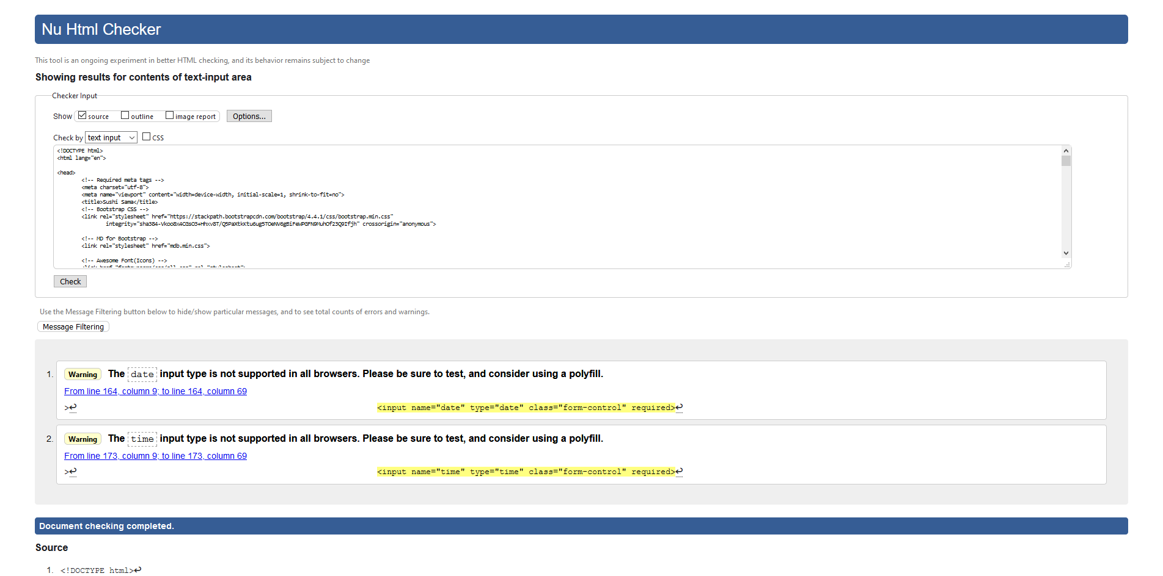

Figure 46: home.html

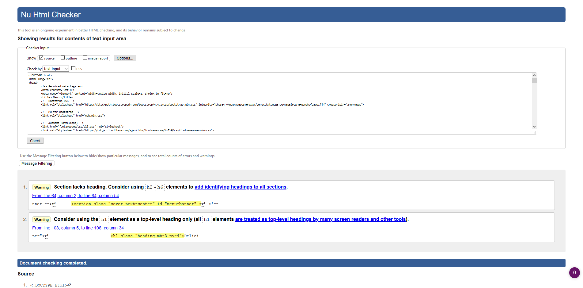

Figure 47: Menu.html

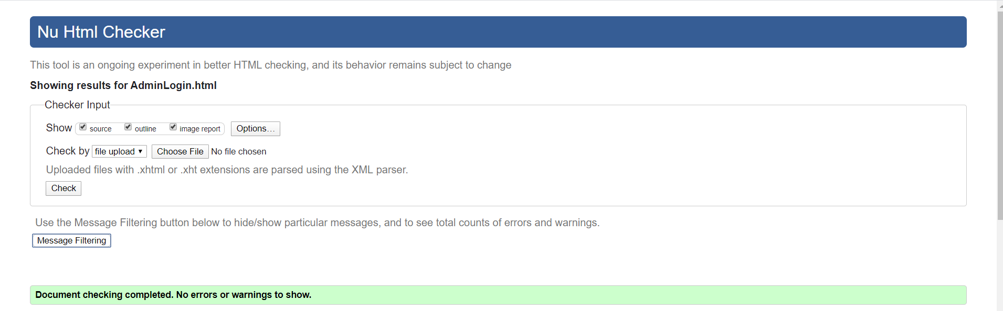

Figure 48: AdminLogin.html

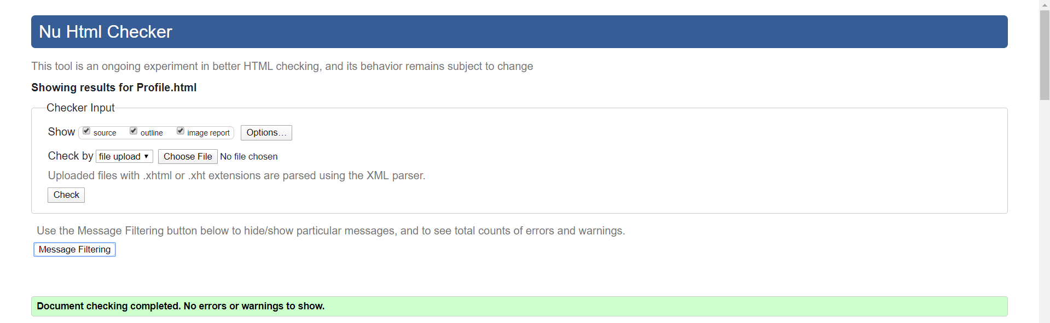

Figure 49: Profile.html

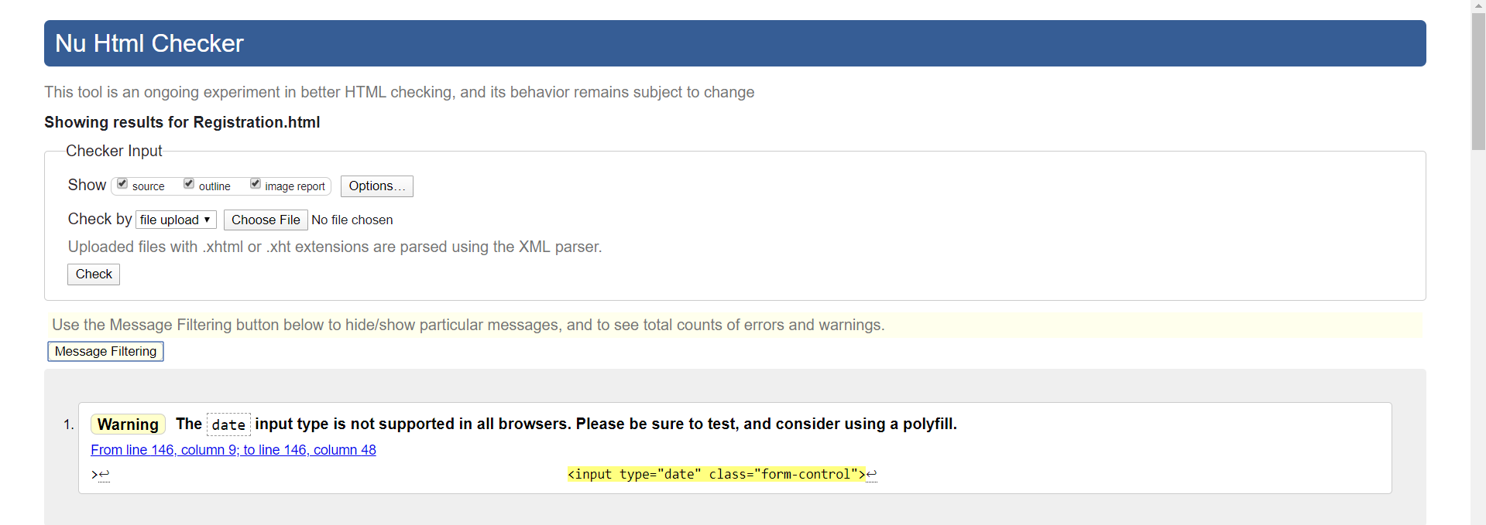

Figure 50: Registration.html

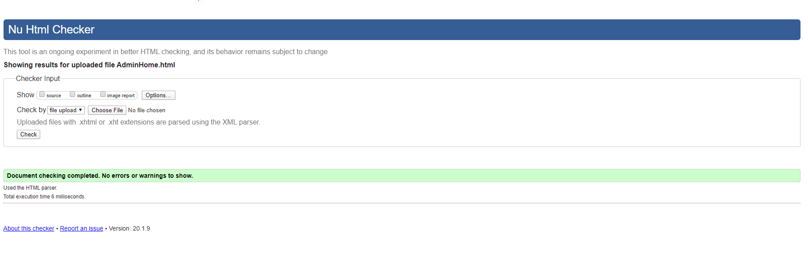

Figure 51: AdminHome.html

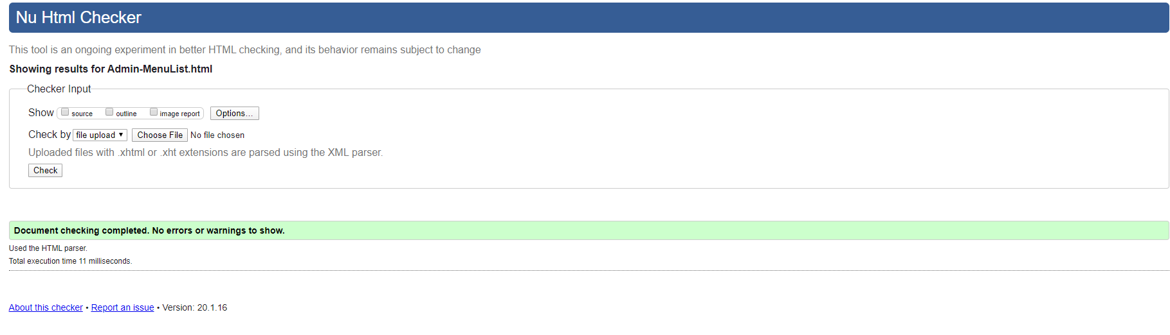

Figure 52: Admin-MenuList.html

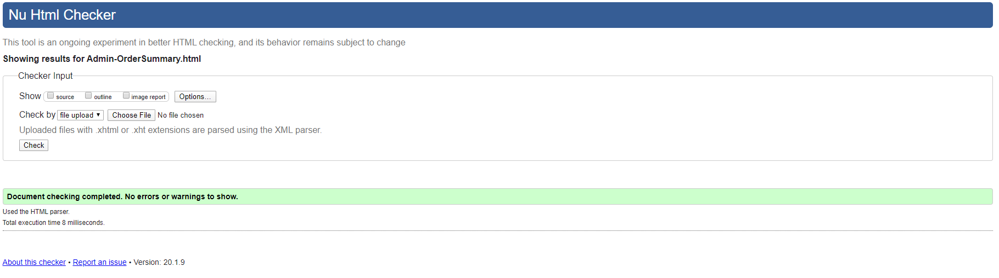

Figure 53: Admin-OrderSummary.html

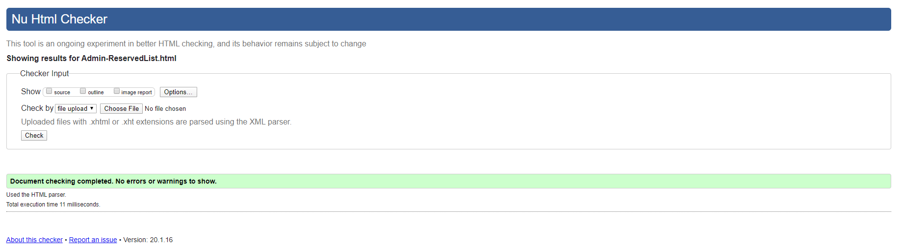

Figure 54: Admin-ReservedList.html

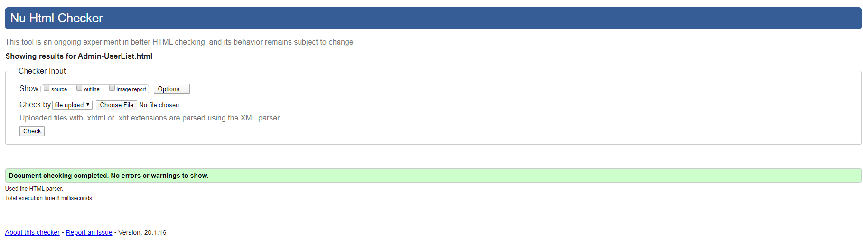

Figure 55: Admin-UserList.html

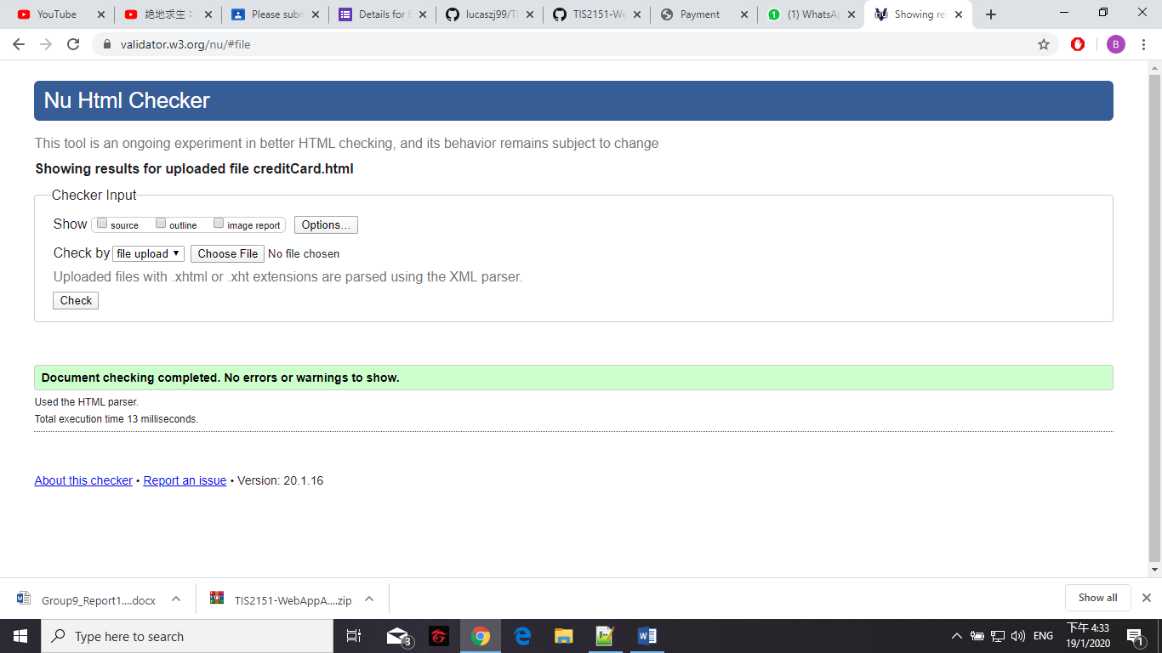

Figure 56: creditCard.html

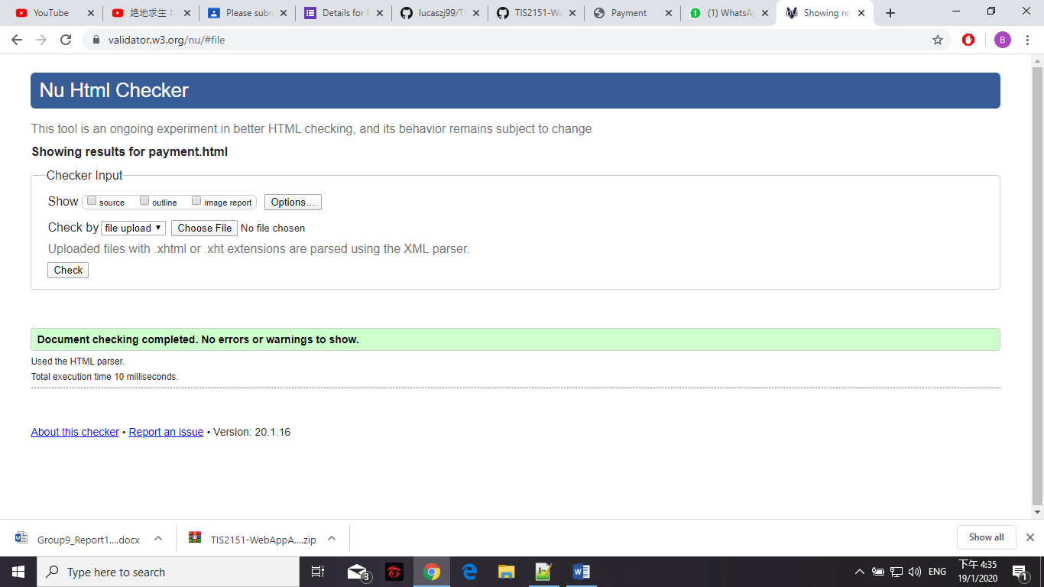

Figure 57: payment.html

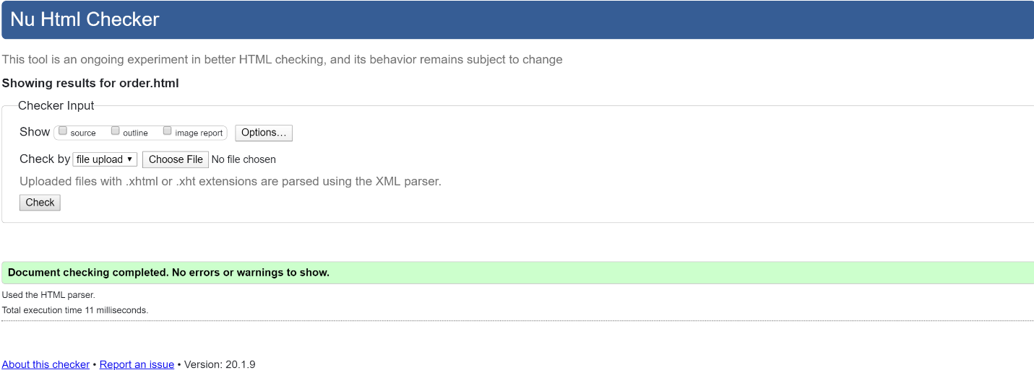 Figure 58: order.html

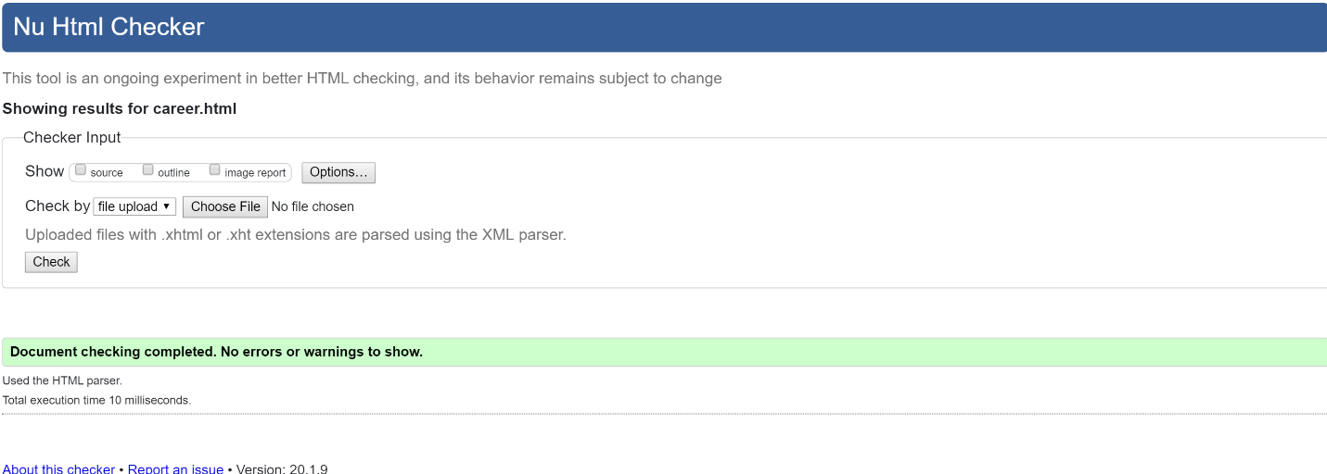 Figure 59: career.html